



**FUNCTIONS**

**1. Write a C program to find a cube of any number using a function.**

#include<stdio.h>

int cube(int num)

{

return (num*num*num);

}

int main()

{

int n,res;

printf("\n Enter a number to find its cube : ");

scanf("%d",&n);

res=cube(n);

printf("\n Cube of %d is %d ",n,res);

return 0;

}

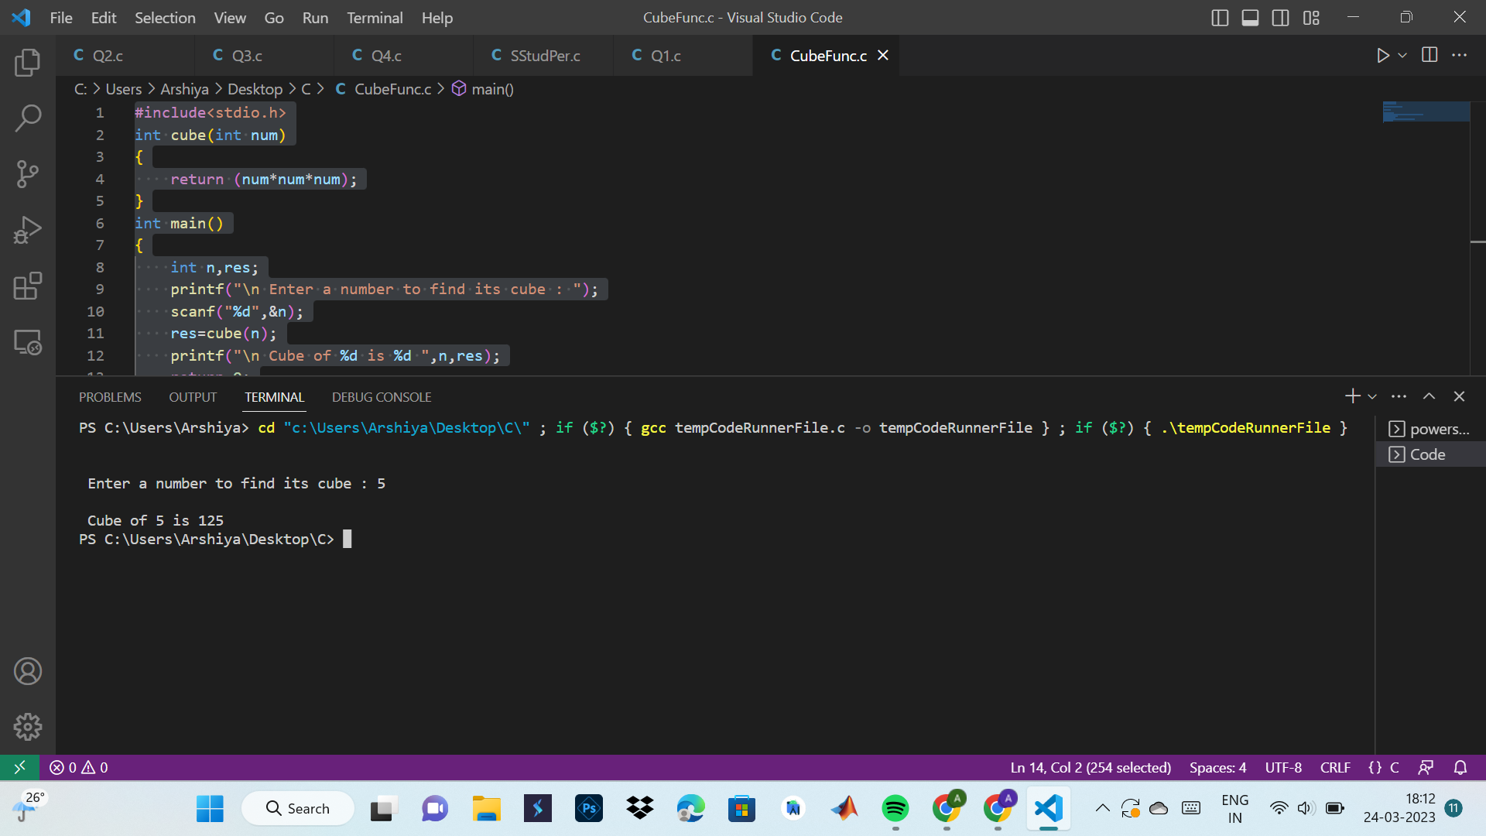

**2. Write a C program to find the diameter, circumference, and area of a circle using functions.**

#include<stdio.h>

float diameter(float rad)

{

return 2*rad;

}

float circumference(float rad)

{

return 2*3.14*rad;

}

float area(float rad)

{

return 3.14*rad*rad;

}

int main()

{

float rad,dia,cir,ar;

printf("\n Enter the radius of circle : ");

scanf("%f",&rad);

dia=diameter(rad);

cir=circumference(rad);

ar=area(rad);

printf("\n Diameter of circle : %f",dia);

printf("\n Circumference of circle : %f",cir);

printf("\n Area of circle : %f",ar);

return 0;

}

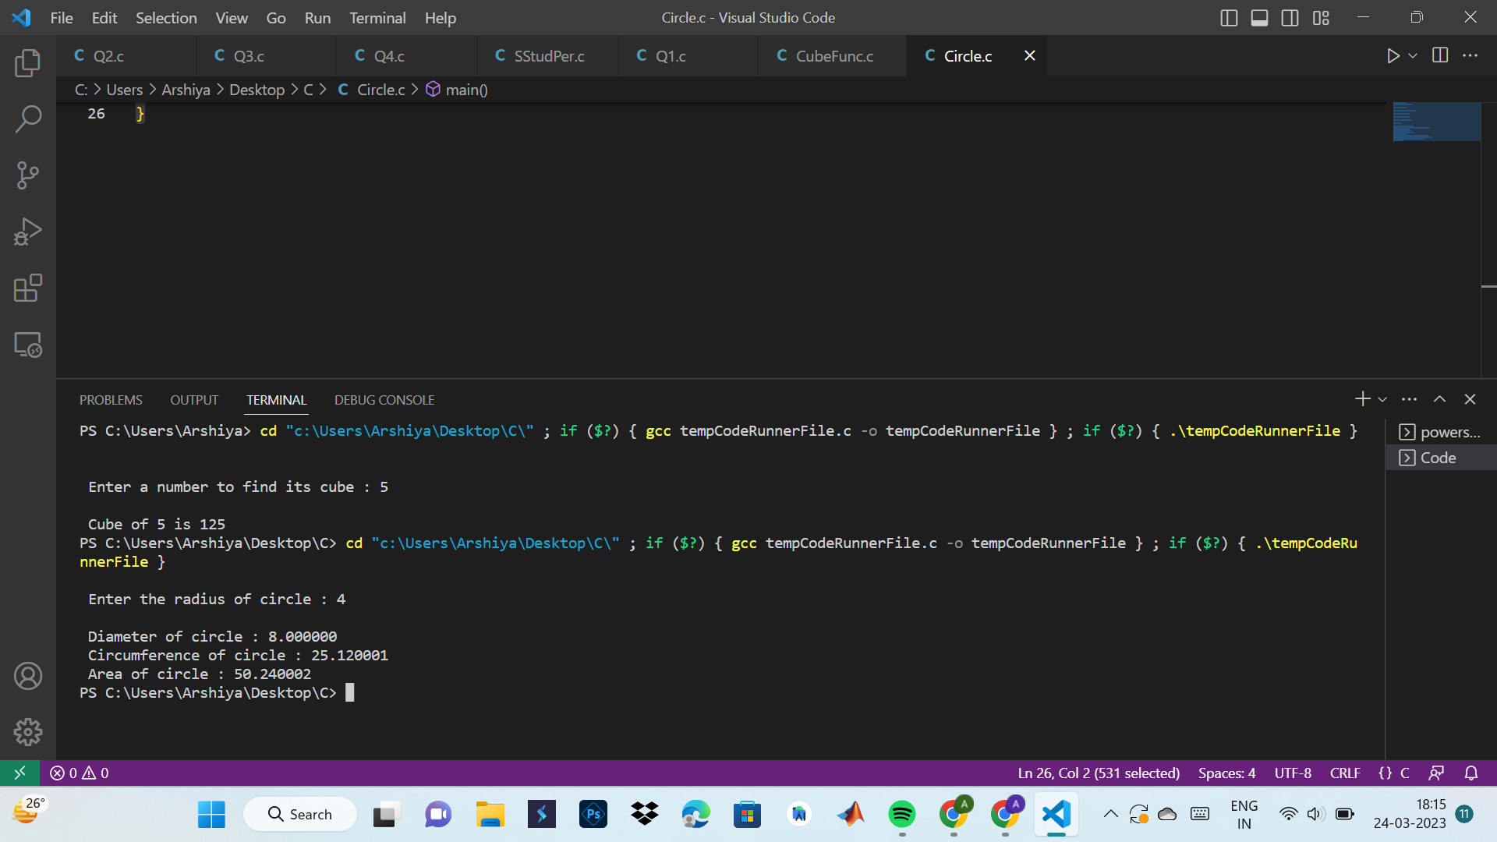

**3. Write a C program to find the maximum and minimum between two numbers using functions.**

#include<stdio.h>

int maxmin(int a,int b)

{

int amax=0;

if(a>b)

{

amax=1;

}

else

{

amax=0;

}

return amax;

}

int main()

{

int a,b,res;

printf("\n Enter num 1 : ");

scanf("%d",&a);

printf("\n Enter num 2 : ");

scanf("%d",&b);

res=maxmin(a,b);

if(res==0)

{

printf("\n Maximum : %d and Minimum : %d",b,a);

}

else

{

printf("\n Maximum : %d and Minimum : %d",a,b);

}

return 0;

}

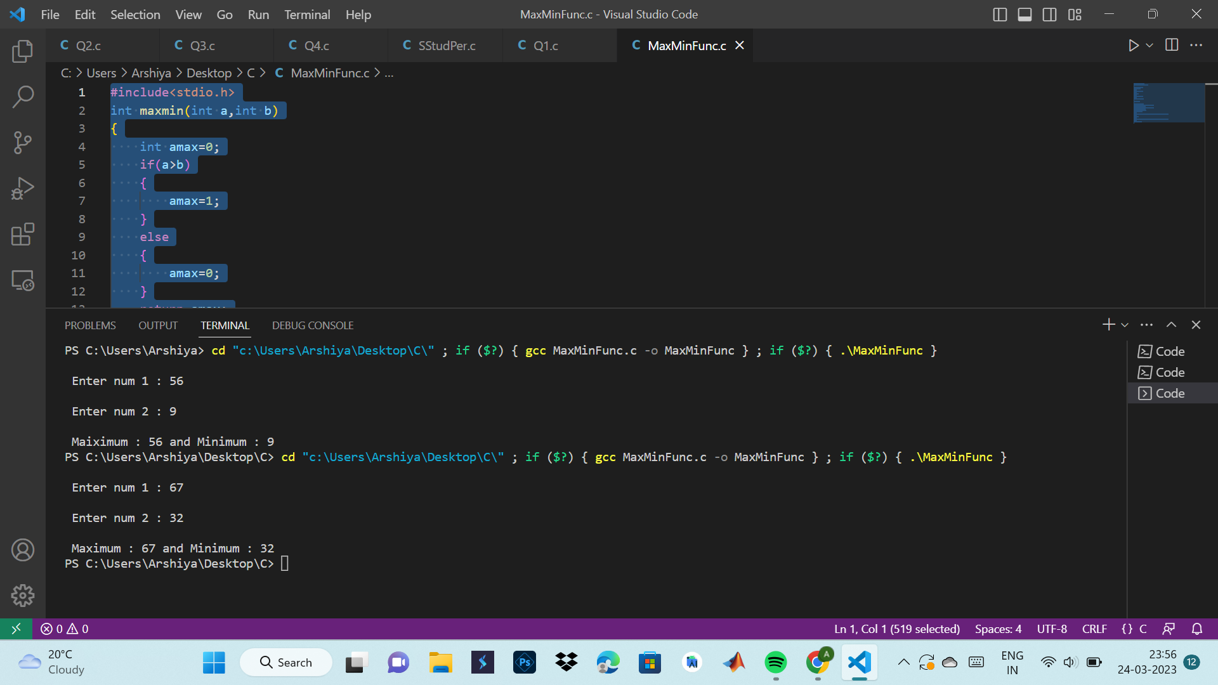

**4. Write a C program to check whether a number is even or odd using functions.**

#include<stdio.h>

int oddeven(int n)

{

int flag=0;

if(n%2==0)

{

flag=1;

}

else

{

flag=0;

}

return flag;

}

int main()

{

int n,res;

printf("\n Enter a number : ");

scanf("%d",&n);

res=oddeven(n);

if(res==0)

{

printf("\n %d is Odd",n);

}

else

{

printf("\n %d is Even",n);

}

return 0;

}

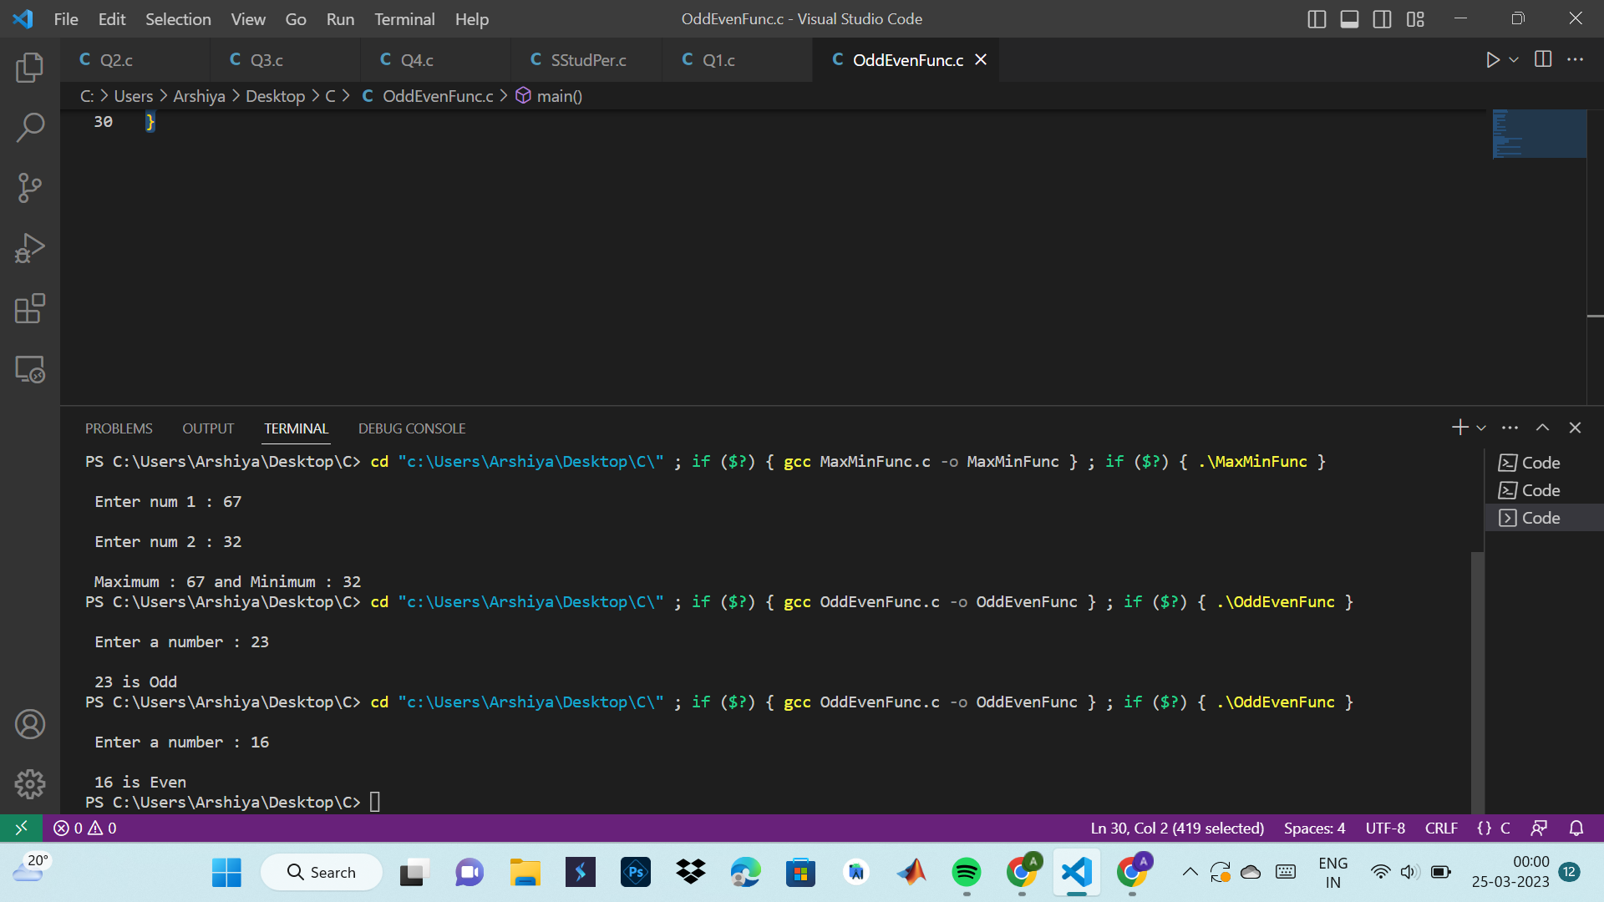

**5. Write a C program to check whether a number is a prime, Armstrong, or perfect number using functions.**

#include<stdio.h>

int isPrime(int n)

{

int i,isprime=0;

if(n==0 || n==1)

{

printf("\n Neither prime nor composite!");

}

else

{

for(i=1;i<=n/2;i++)

{

if(n%i==0)

{

isprime=1;

}

else

{

isprime=0;

}

}

}

return isprime;

}

int isArmstrong(int n)

{

int ld=0,pow=0,sum=0;

int num=n;

int isarmstrong=0;

while(num!=0)

{

ld=num%10;

pow=ld*ld*ld;

sum+=pow;

num/=10;

}

if(sum==n)

{

isarmstrong=1;

}

else

{

isarmstrong=0;

}

return isarmstrong;

}

int isPerfect(int n)

{

int i,sum=0;

int isperfect=0;

for(i=1;i<=n/2;i++)

{

if(n%i==0)

{

sum+=i;

}

}

if(sum==n)

{

isperfect=1;

}

else

{

isperfect=0;

}

return isperfect;

}

int main()

{

int n;

int checkprime,checkarmstrong,checkperfect;

printf("\n Enter a number : ");

scanf("%d",&n);

checkprime=isPrime(n);

if(checkprime==0)

{

printf("\n %d is prime",n);

}

else if(checkprime==1)

{

printf("\n %d is not prime",n);

}

checkarmstrong=isArmstrong(n);

if(checkarmstrong==1)

{

printf("\n %d is an armstrong number",n);

}

else if(checkarmstrong==0)

{

printf("\n %d is not an armstrong number",n);

}

checkperfect=isPerfect(n);

if(checkperfect==1)

{

printf("\n %d is a perfect number",n);

}

else if(checkperfect==0)

{

printf("\n %d is not a perfect number",n);

}

return 0;

}

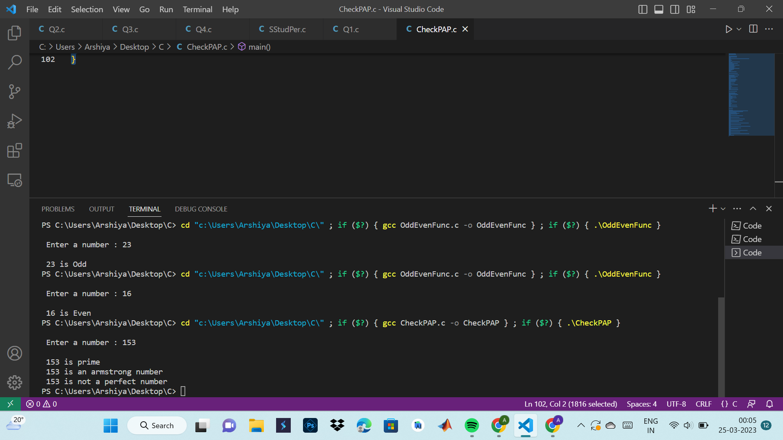

**6. Write a C program to find all prime numbers between given intervals using functions.**

#include<stdio.h>

int checkPrime(int n)

{

int j, flag=1;

for(j=2;j<=n/2;j++)

{

if(n%j==0)

{

flag=0;

break;

}

}

return flag;

}

int main()

{

int n1,n2,i,flag;

printf("\n Enter num 1 : ");

scanf("%d",&n1);

printf("\n Enter num 2 : ");

scanf("%d",&n2);

if(n1>n2)

{

n1=n1+n2;

n2=n1-n2;

n1=n1-n2;

}

printf("\n Prime numbers between %d and %d are : ",n1,n2);

for(i=n1;i<=n2;i++)

{

flag=checkPrime(i);

if(flag==1)

{

printf("%d ",i);

}

}

return 0;

}

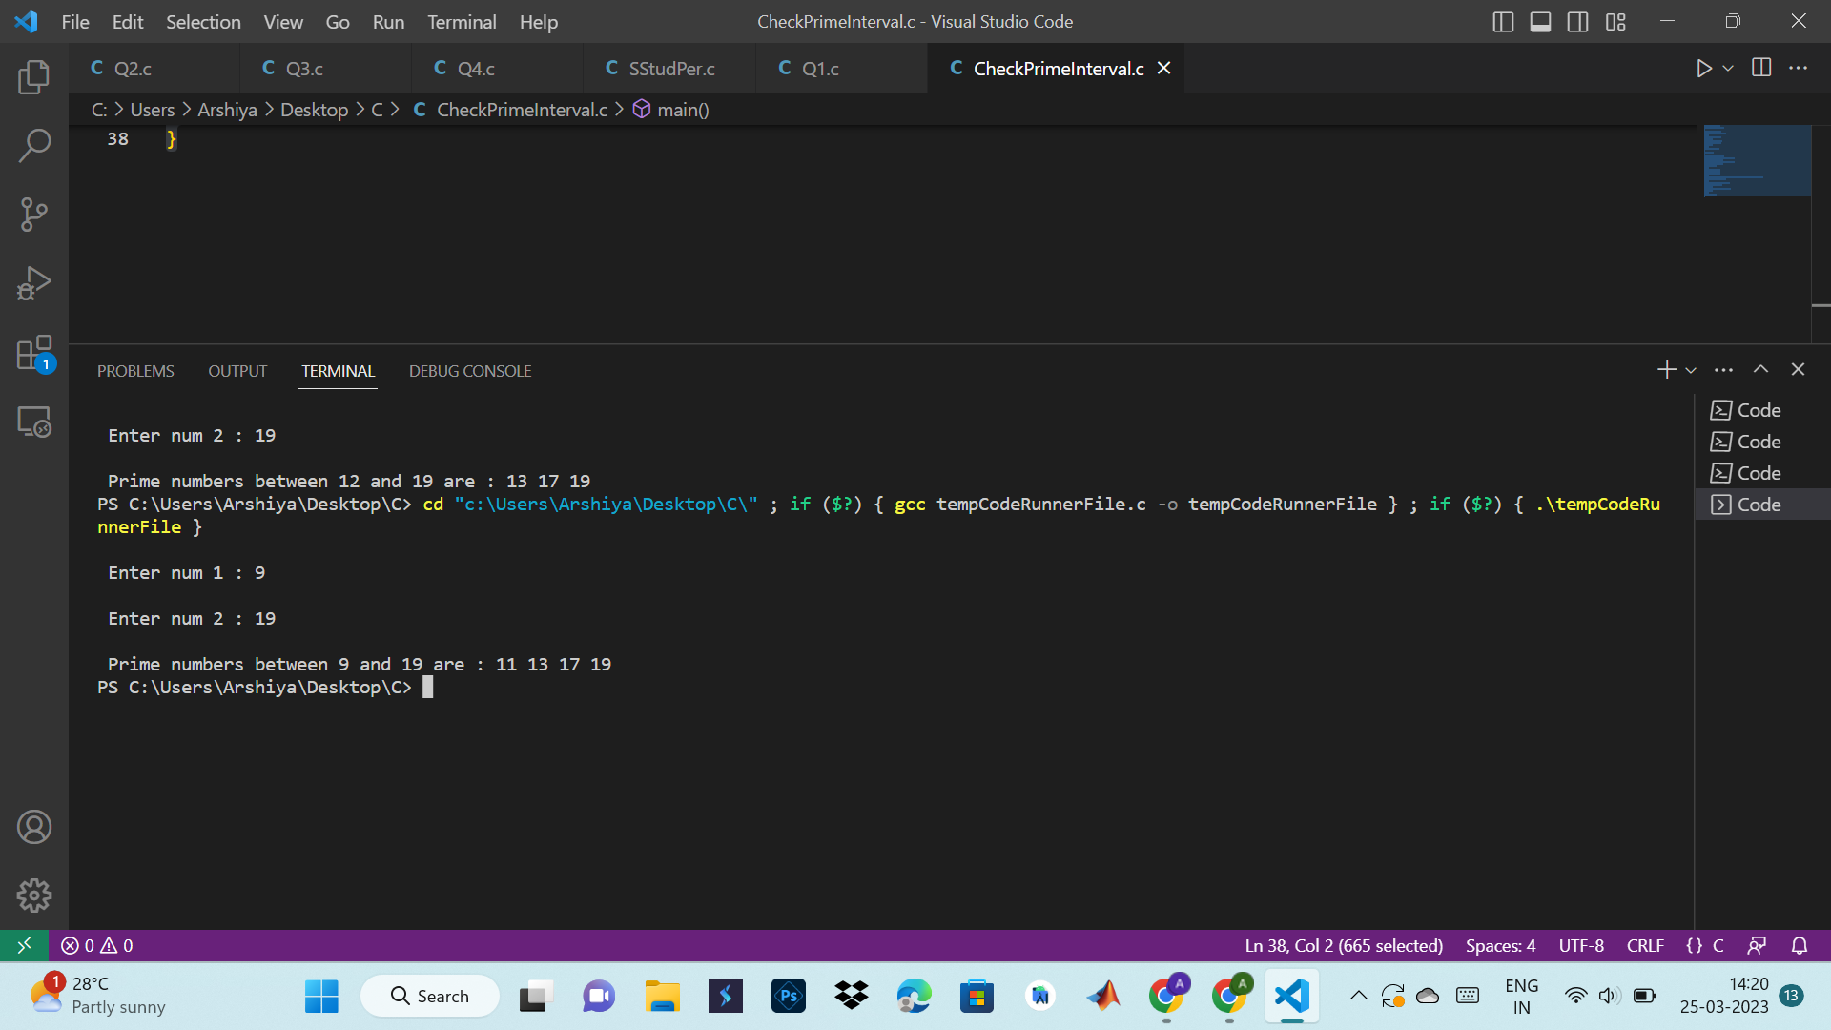

**7. Write a C program to print all Armstrong numbers between given intervals using functions.**

#include<stdio.h>

#include<math.h>

float checkArmstrong(int num)

{

int rem, n=0,t;

float sum = 0.0;

t=num;

while(t)

{

t=t/10;

n++;

}

while(num)

{

rem=num%10;

sum=sum+pow(rem,n);

num=num/10;

}

return(sum);

}

int main()

{

int i,s,e,t;

printf("\n Enter start value of range : ");

scanf("%d",&s);

printf("\n Enter end value of range : ");

scanf("%d",&e);

if(s>e)

{

t=s;

s=e;

e=t;

}

printf("\n Armstrong numbers between %d and %d are \n ",s,e);

for(i=s;i<=e;i++)

{

if(i==checkArmstrong(i))

{

printf("%d is an Armstrong number \n",i);

}

}

return 0;

}

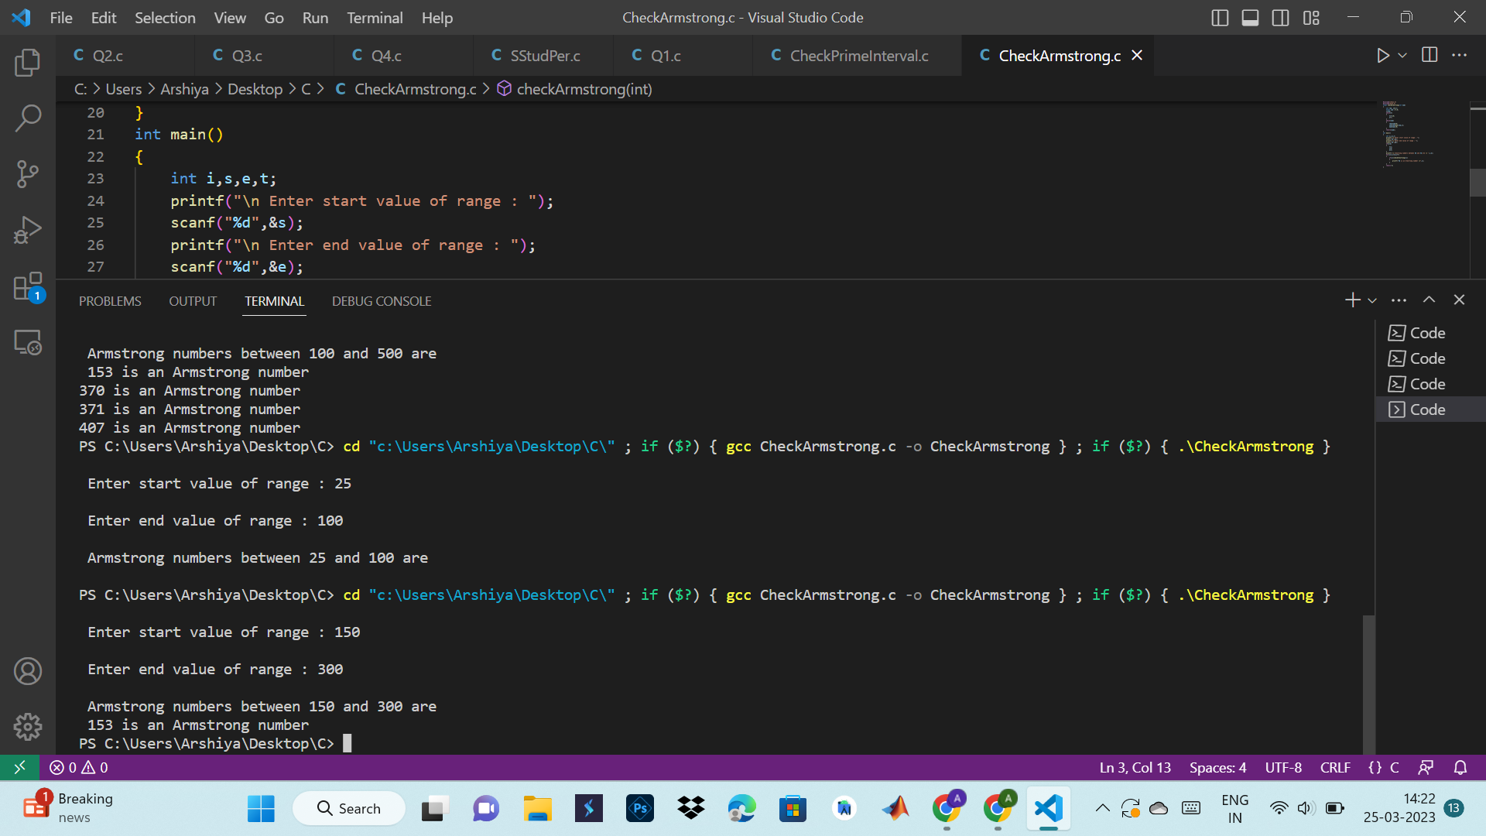

**8. Write a C program to print all perfect numbers between given intervals using functions.**

#include<stdio.h>

int isPerfect(int n)

{

int i,sum;

sum=0;

for(i=1;i<n;i++)

{

if(n%i==0)

{

sum+=i;

}

}

if(sum==n)

{

return 1;

}

else

return 0;

}

void printPerfect(int s, int e)

{

while(s<=e)

{

if(isPerfect(s))

{

printf("%d ",s);

}

s++;

}

}

int main()

{

int s,e;

printf("\n Enter start limit : ");

scanf("%d",&s);

printf("\n Enter end limit : ");

scanf("%d",&e);

printf("\n All perefct numbers between %d and %d are : ",s,e);

printPerfect(s,e);

return 0;

}

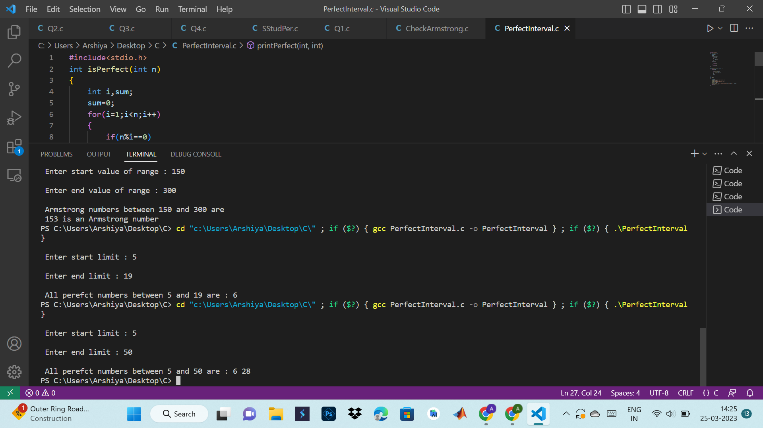

**9. Write a program in C to check whether two given strings are an anagram.**

#include<stdio.h>

int checkAnagram(char str1[], char str2[])

{

int n1[26]={0}, n2[26]={0}, i=0;

while(str1[i]!='\0')

{

n1[str1[i]-'a']++;

i++;

}

i=0;

while(str2[i]!='\0')

{

n2[str2[i]-'a']++;

i++;

}

for(i=0;i<26;i++)

{

if(n1[i]!=n2[i])

{

return 0;

}

}

return 1;

}

int main()

{

char str1[100],str2[100];

int flag;

printf("\n Enter string 1 : ");

gets(str1);

printf("\n Enter string 2 : ");

gets(str2);

flag=checkAnagram(str1,str2);

if(flag==1)

{

printf("%s and %s are anagrams ",str1,str2);

}

else

{

printf("%s and %s are not anagrams ",str1,str2);

}

return 0;

}

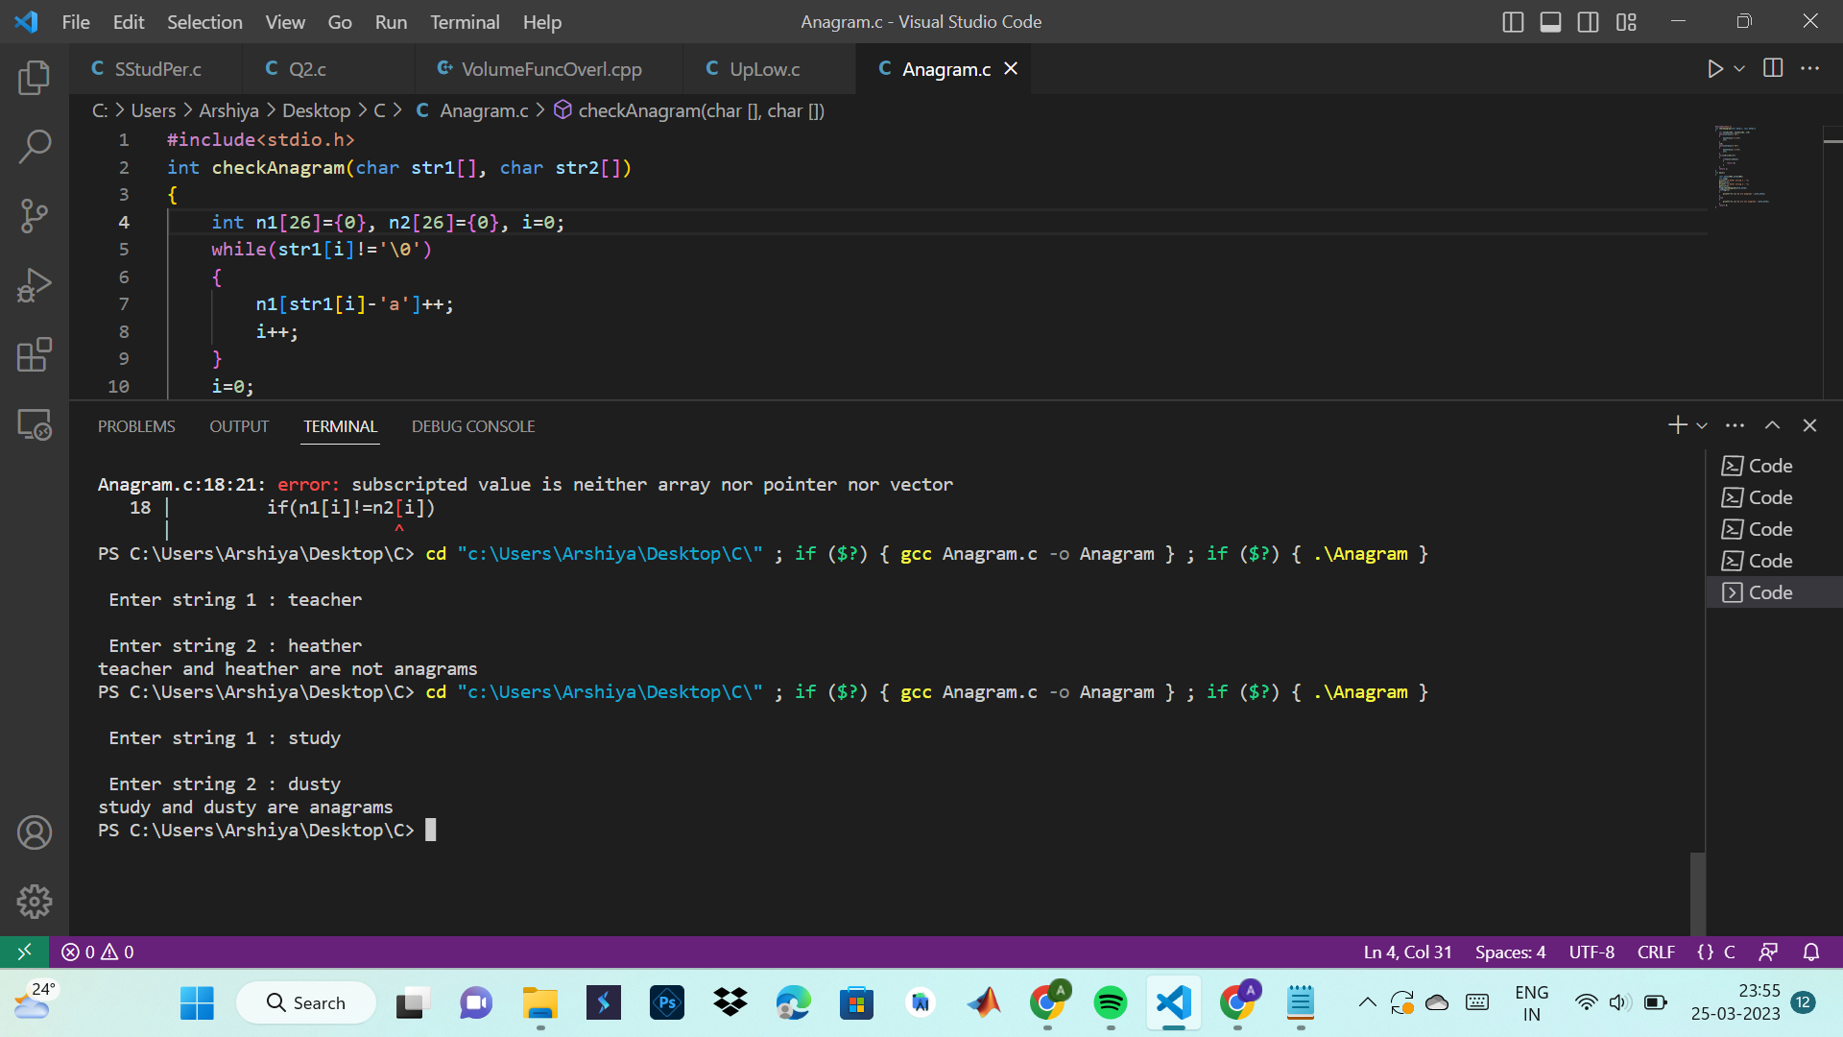

**10. Write a C programming to find out the maximum and minimum of some values using a function which will return an array.**

# include <stdio.h>

# define max 10

int *maxmin(int ar[], int v);

int main()

{

int arr[max];

int n,i, *p;

printf("Enter size of array: ");

scanf("%d",&n);

printf("Input %d values\n", n);

for(i=0;i<n;i++)

scanf("%d",&arr[i]);

p=maxmin(arr,n);

printf("Minimum value is: %d\n",*p++);

printf("Maximum value is: %d\n",*p);

getch();

}

int *maxmin(int arra1[], int v)

{

int i;

static int result_mm[2];

result_mm[0]=arra1[0];

result_mm[1]=arra1[0];

for (i=1;i<v;i++)

{

if(result_mm[0] > arra1[i])

result_mm[0]=arra1[i];

if(result_mm[1]< arra1[i])

result_mm[1]= arra1[i];

}

return result_mm;

}

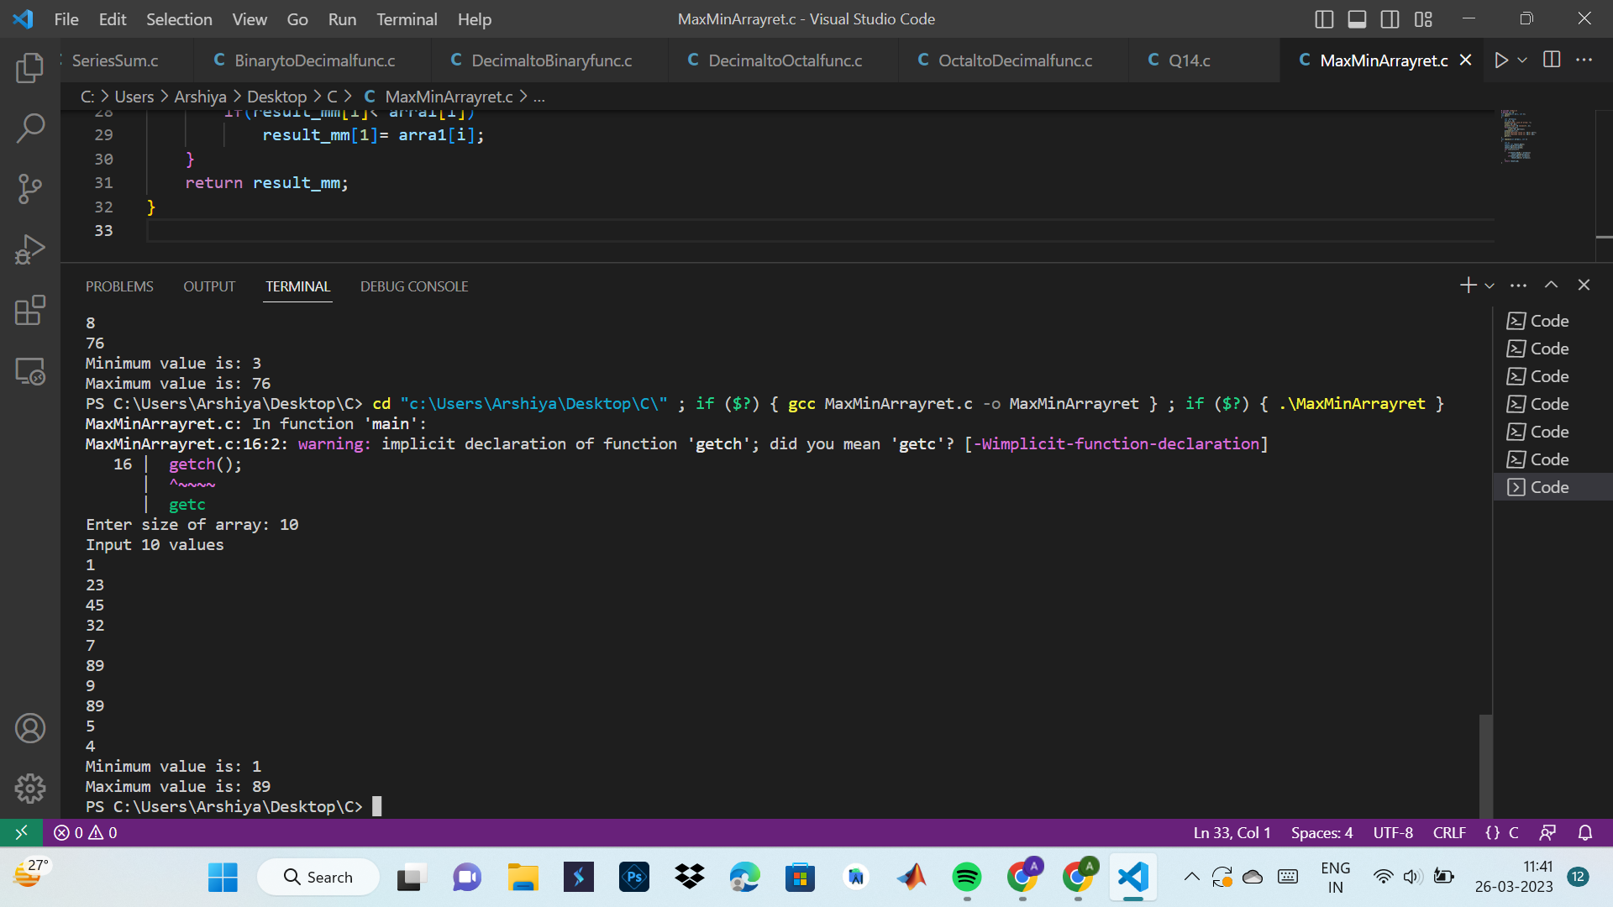

**7**

**11.Convert a binary number to an octal and vice versa using functions.**

#include<stdio.h>

#include<math.h>

void decimaltooctal(int n){

int i=0;

int octalnum[32];//(0to31) //? what's should be good choice of array here.

while(n!=0){

octalnum[i]=n%8;

n = n/8;

i++;

}

printf("Octal number is: ");

for(int j=(i-1);j>=0;j--){

printf("%d", octalnum[j]);

}

}

int main(){

int n;

printf("Enter the binary number:");

scanf("%d", &n);

int i=0;int ans = 0;

while(n!=0){

int digit = n%10;

ans = pow(2,i)*digit + ans; //formula.

n =n/10;

i++;

}

decimaltooctal(ans);

return 0;

}

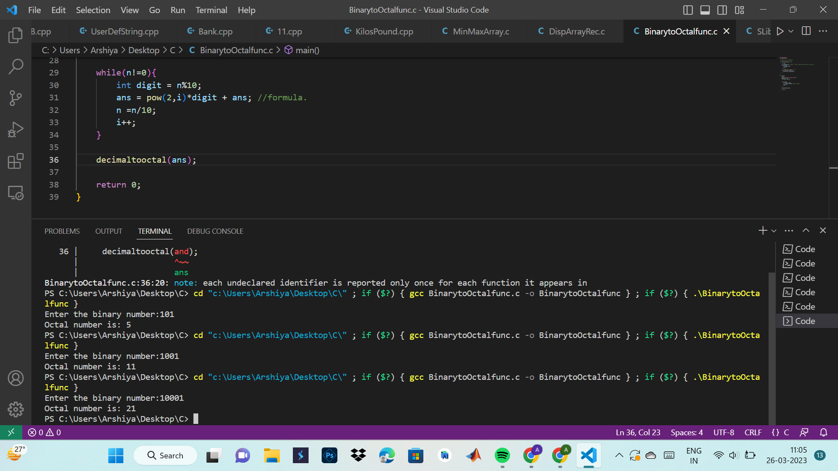

#include <math.h>

#include <stdio.h>

long long convert(int oct);

int main() {

int oct;

printf("Enter an octal number: ");

scanf("%d", &oct);

printf("%d in octal = %lld in binary", oct, convert(oct));

return 0;

}

long long convert(int oct) {

int dec = 0, i = 0;

long long bin = 0;

// converting octal to decimal

while (oct != 0) {

dec += (oct % 10) * pow(8, i);

++i;

oct /= 10;

}

i = 1;

// converting decimal to binary

while (dec != 0) {

bin += (dec % 2) * i;

dec /= 2;

i *= 10;

}

return bin;

}

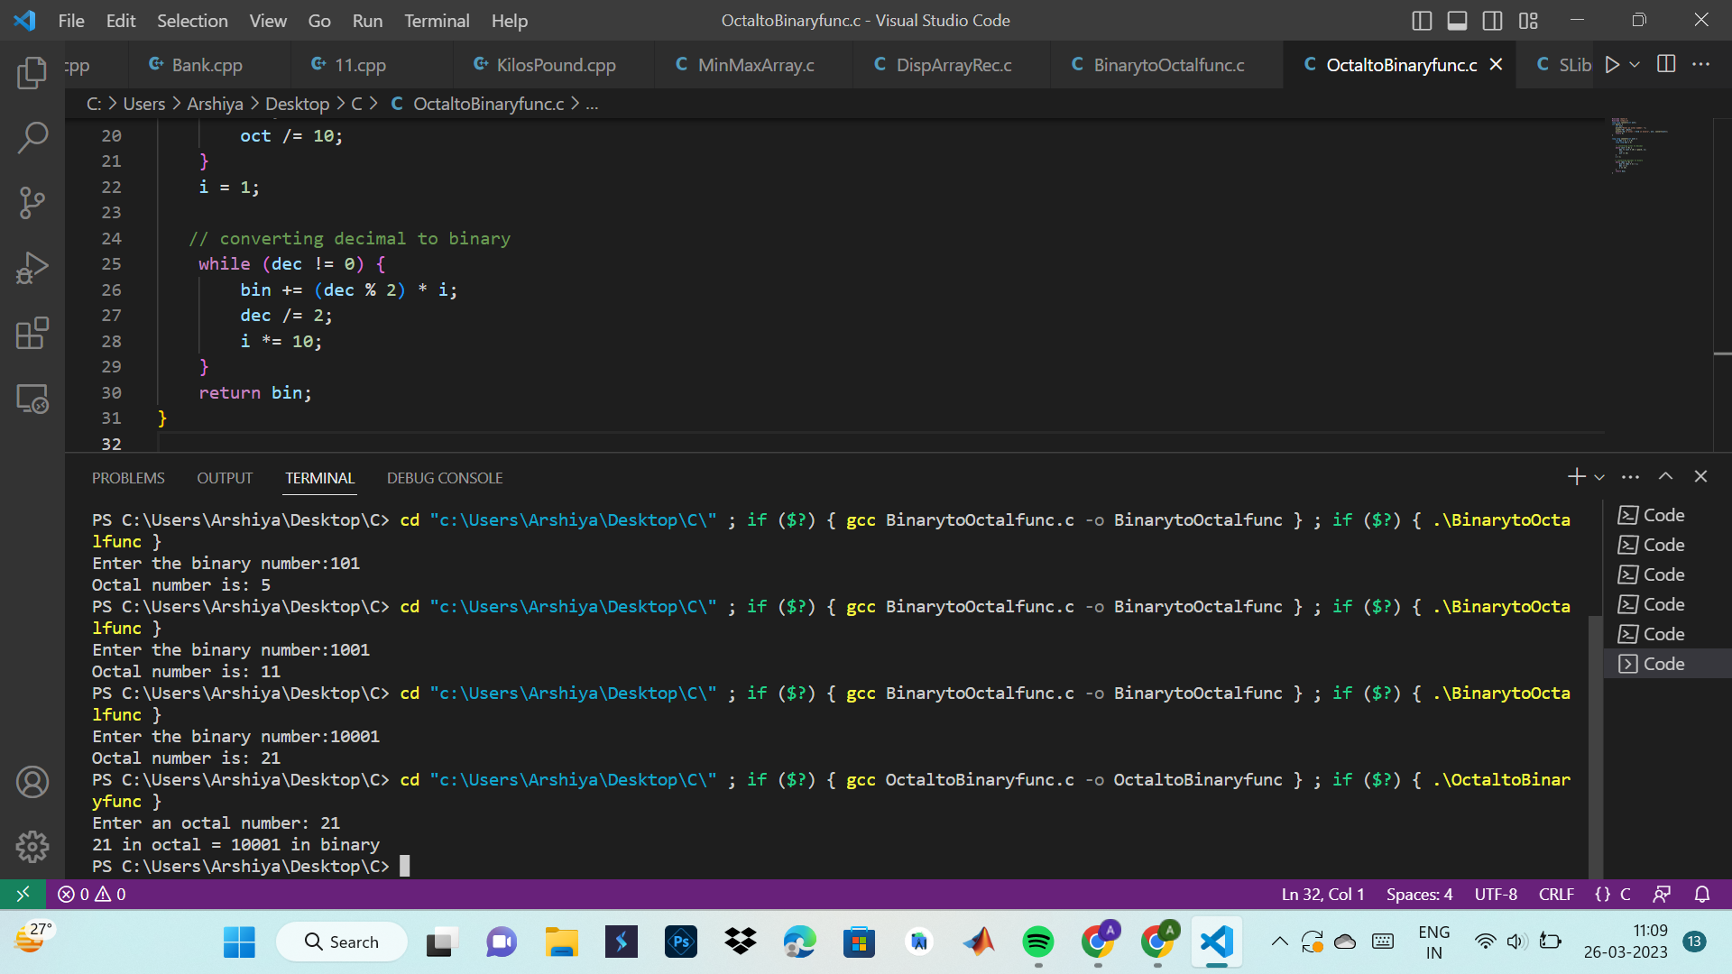

**12. Convert a binary number to a decimal and vice versa using functions.**

#include <stdio.h>

#include <math.h>

// function prototype

int convert(long long);

int main() {

long long n;

printf("Enter a binary number: ");

scanf("%lld", &n);

printf("%lld in binary = %d in decimal", n, convert(n));

return 0;

}

// function definition

int convert(long long n) {

int dec = 0, i = 0, rem;

while (n!=0) {

rem = n % 10;

n /= 10;

dec += rem * pow(2, i);

++i;

}

return dec;

}

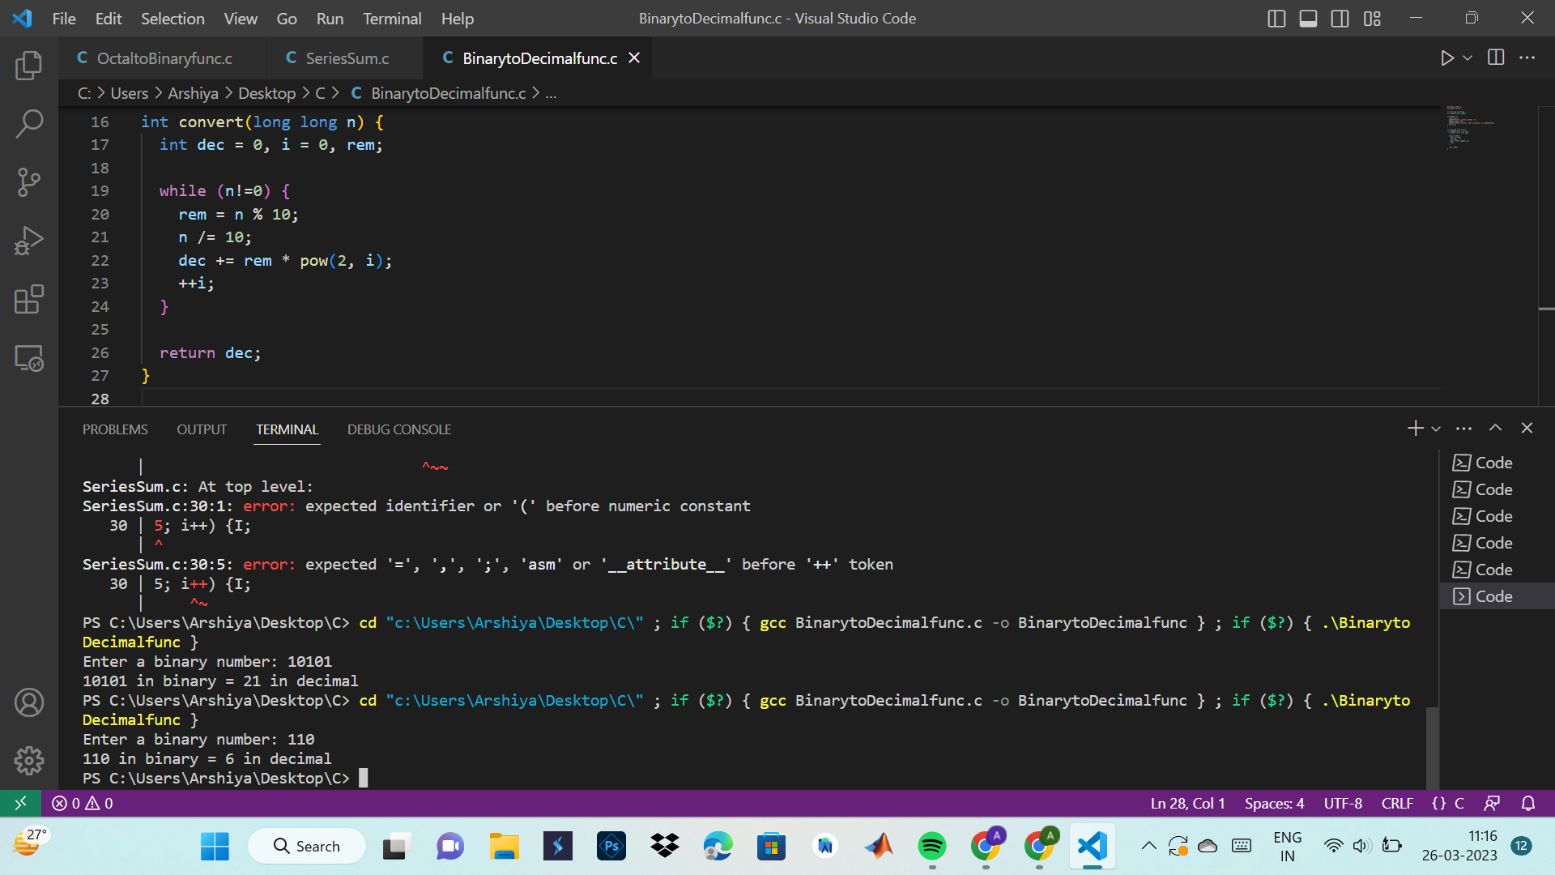

#include<stdio.h>

long toBin(int);

int main()

{

long bno;

int dno;

printf("\n\n Function : convert decimal to binary :\n");

printf("-------------------------------------------\n");

printf(" Input any decimal number : ");

scanf("%d",&dno);

bno = toBin(dno);

printf("\n The Binary value is : %ld\n\n",bno);

return 0;

}

long toBin(int dno)

{

long bno=0,remainder,f=1;

while(dno != 0)

{

remainder = dno % 2;

bno = bno + remainder * f;

f = f * 10;

dno = dno / 2;

}

return bno;

}

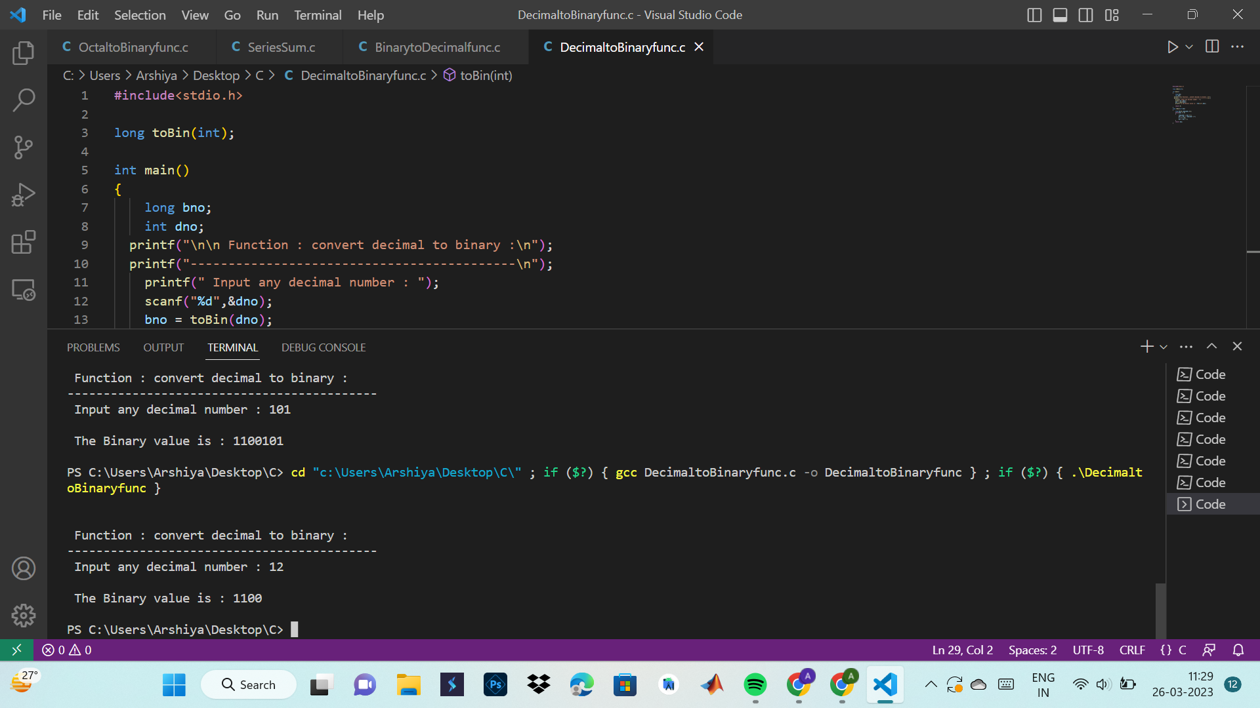

**13. Convert an octal Number to a decimal and vice versa using functions.**

#include <stdio.h>

#include <math.h>

// function prototype

int convertDecimalToOctal(int decimalNumber);

int main() {

int decimalNumber;

printf("Enter a decimal number: ");

scanf("%d", &decimalNumber);

printf("%d in decimal = %d in octal", decimalNumber, convertDecimalToOctal(decimalNumber));

return 0;

}

// function to convert decimalNumber to octal

int convertDecimalToOctal(int decimalNumber) {

int octalNumber = 0, i = 1;

while (decimalNumber != 0) {

octalNumber += (decimalNumber % 8) * i;

decimalNumber /= 8;

i *= 10;

}

return octalNumber;

}

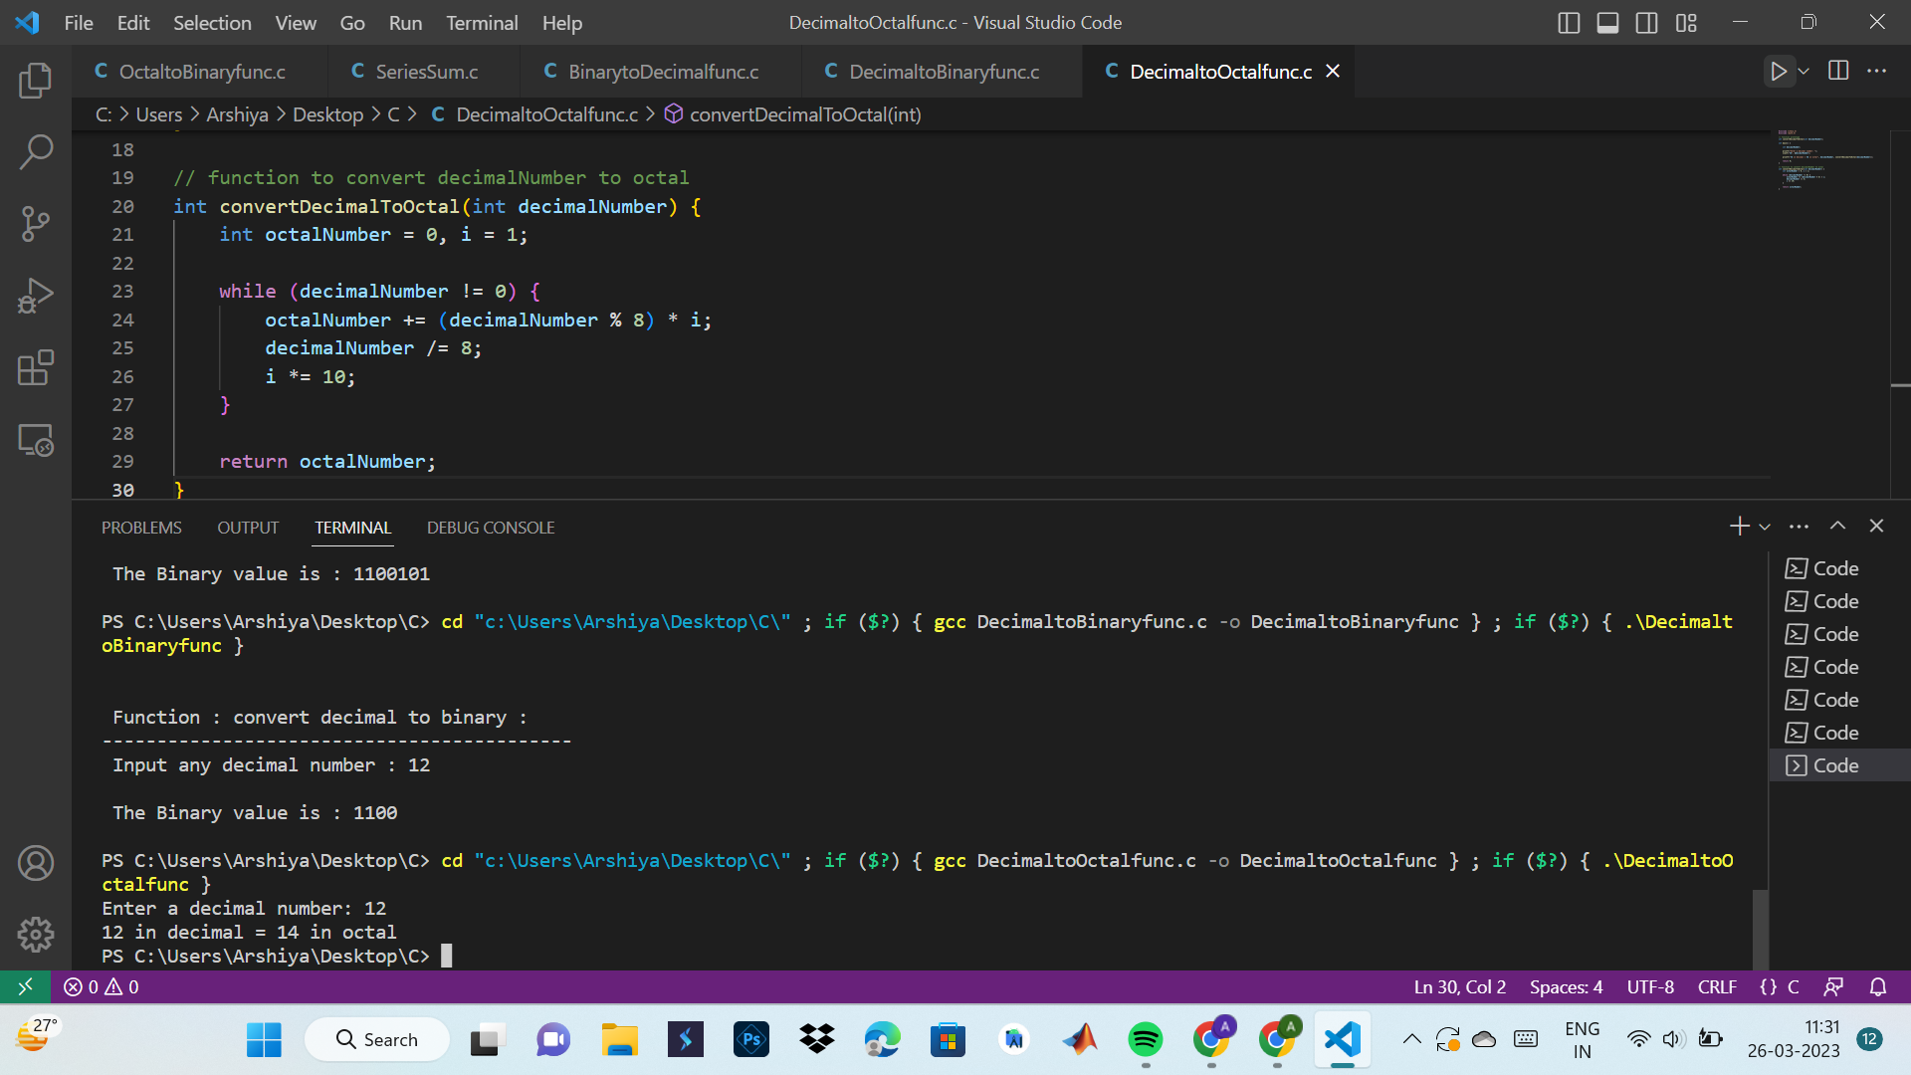

#include <stdio.h>

#include <math.h>

// function prototype

long long convertOctalToDecimal(int octalNumber);

int main() {

int octalNumber;

printf("Enter an octal number: ");

scanf("%d", &octalNumber);

printf("%d in octal = %lld in decimal", octalNumber, convertOctalToDecimal(octalNumber));

return 0;

}

// function to convert octalNumber to decimal

long long convertOctalToDecimal(int octalNumber) {

int decimalNumber = 0, i = 0;

while(octalNumber != 0) {

decimalNumber += (octalNumber%10) * pow(8,i);

++i;

octalNumber/=10;

}

i = 1;

return decimalNumber;

}

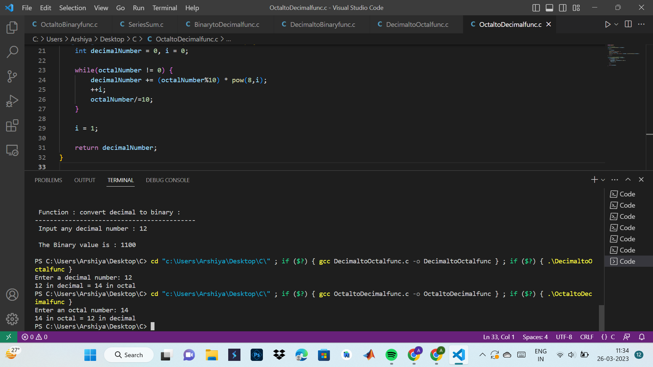

**14. Write a program in C to find the sum of the series 1!/1+2!/2+3!/3+4!/4+5!/5 using the**

**function.**

#include <stdio.h>

int factorial(int n) {

int i, f = 1;

for (i = 1; i <= n; i++) {

f = f * i;

}

return f;

}

int main() {

int i;

float sum = 0;

for (i = 1; i <= 5; i++) {

sum = sum + (float)factorial(i) / i;

}

printf("Sum of the series = %f", sum);

return 0;

}

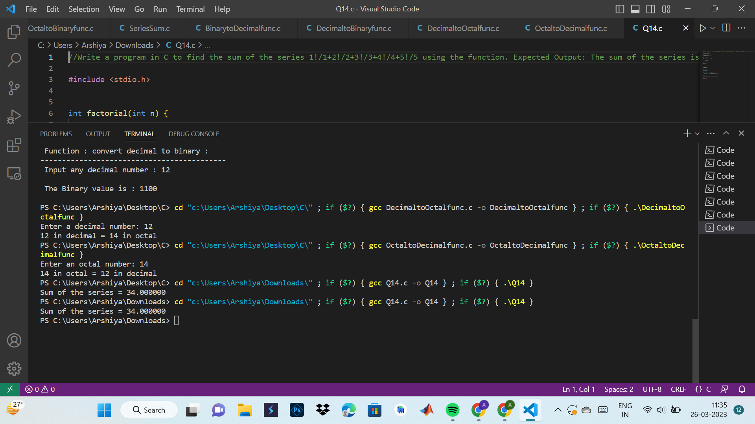

**15. Write a C program to find the power of any number using recursion.**

#include<stdio.h>

int power(int b, int e)

{

if(e==0)

return 1;

else if(e>0)

return b*power(b,e-1);

else

return 1/power(b,-e);

}

int main()

{

int b,p,e;

printf("\n Enter base : ");

scanf("%d",&b);

printf("\n Enter exponent : ");

scanf("%d",&e);

p=power(b,e);

printf("\n %d ^ %d = %d",b,e,p);

return 0;

}

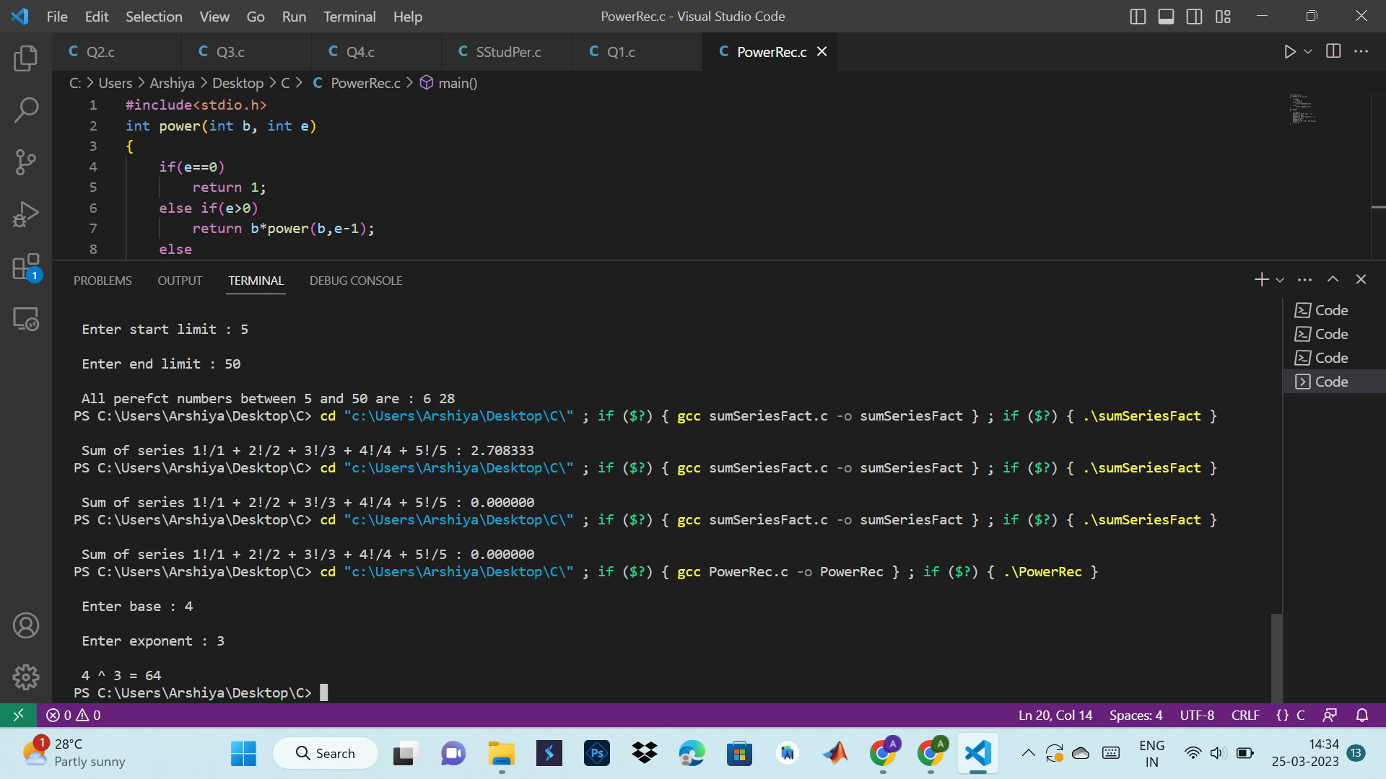

**16. Write a C program to print all natural numbers between 1 to n using recursion.**

#include<stdio.h>

void printNum(int n)

{

if(n>1)

printNum(n-1);

printf("%d ",n);

}

int main()

{

int n;

printf("\n Enter range till which you want the numbers to be printed : ");

scanf("%d",&n);

printf("\n Natural numbers from 1 to %d are : ",n);

printNum(n);

return 0;

}

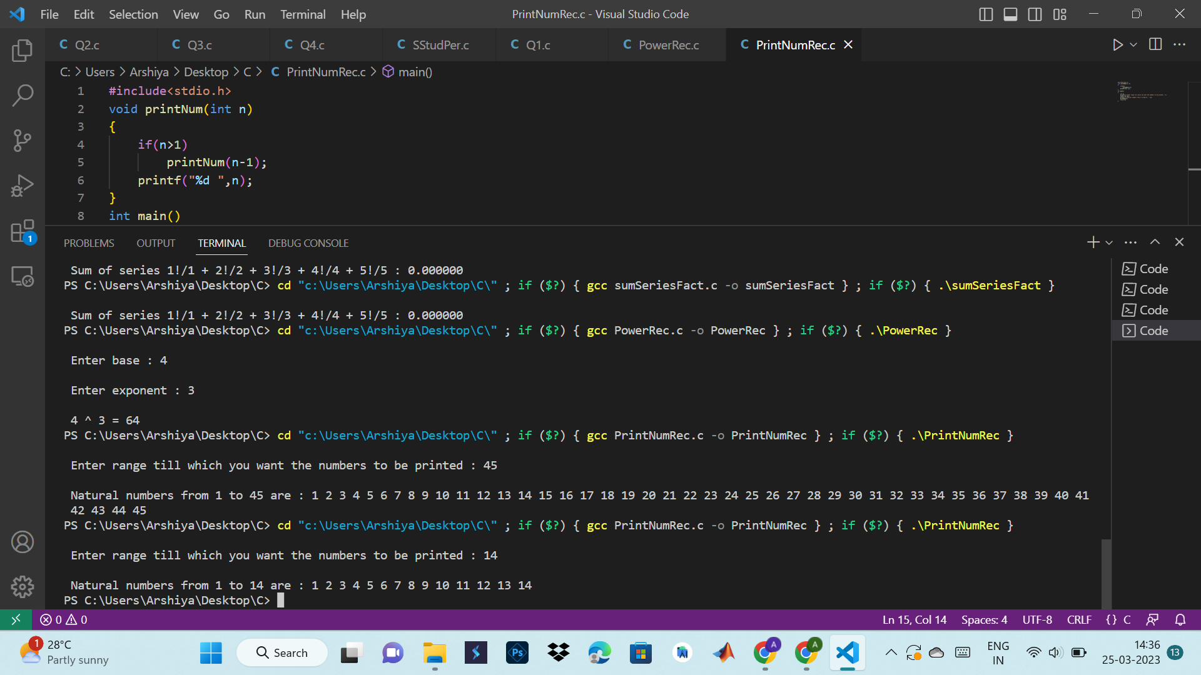

**17. Write a C program to print all even or odd numbers in a given range using recursion.**

#include<stdio.h>

void printEvenOdd(int s,int e)

{

if(s>e)

{

return;

}

printf("%d ",s);

printEvenOdd(s+2,e);

}

int main()

{

int s,e;

printf("\n Enter start of range : ");

scanf("%d",&s);

printf("\n Enter end of range : ");

scanf("%d",&e);

printf("\n Even/Odd numbers between %d and %d are - ",s,e);

printEvenOdd(s,e);

return 0;

}

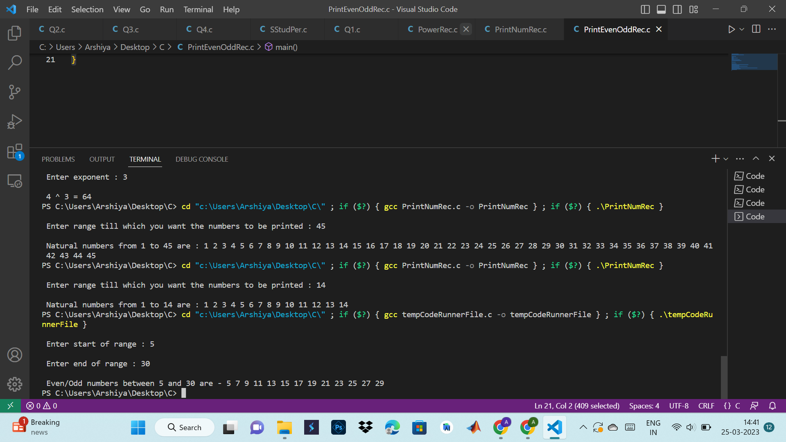

**18. Write a C program to find the sum of all natural numbers between 1 to n using recursion.**

#include<stdio.h>

int sumnum(int n)

{

if(n!=0)

return n+sumnum(n-1);

else

return n;

}

int main()

{

int n;

printf("\n Enter a number : ");

scanf("%d",&n);

printf("\n Sum from 1 to %d = %d ",n,sumnum(n));

return 0;

}

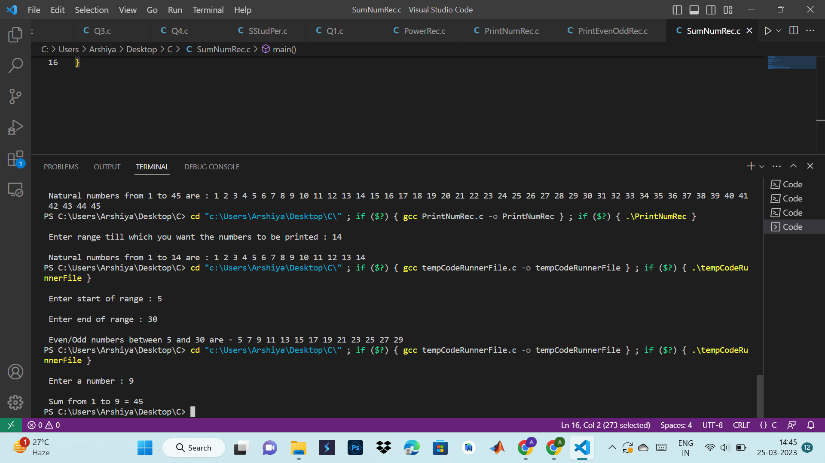

**19. Write a C program to find the sum of all even or odd numbers in a given range using**

**recursion.**

#include<stdio.h>

int evenoddSum(int s, int e)

{

if(s>e)

return 0;

else

return (s+evenoddSum(s+2,e));

}

int main()

{

int s,e,sum;

printf("\n Enter lower limit : ");

scanf("%d",&s);

printf("\n Enter upper limit : ");

scanf("%d",&e);

printf("\n Sum of even or odd numbers between % d and %d is %d ",s,e,evenoddSum(s,e));

return 0;

}

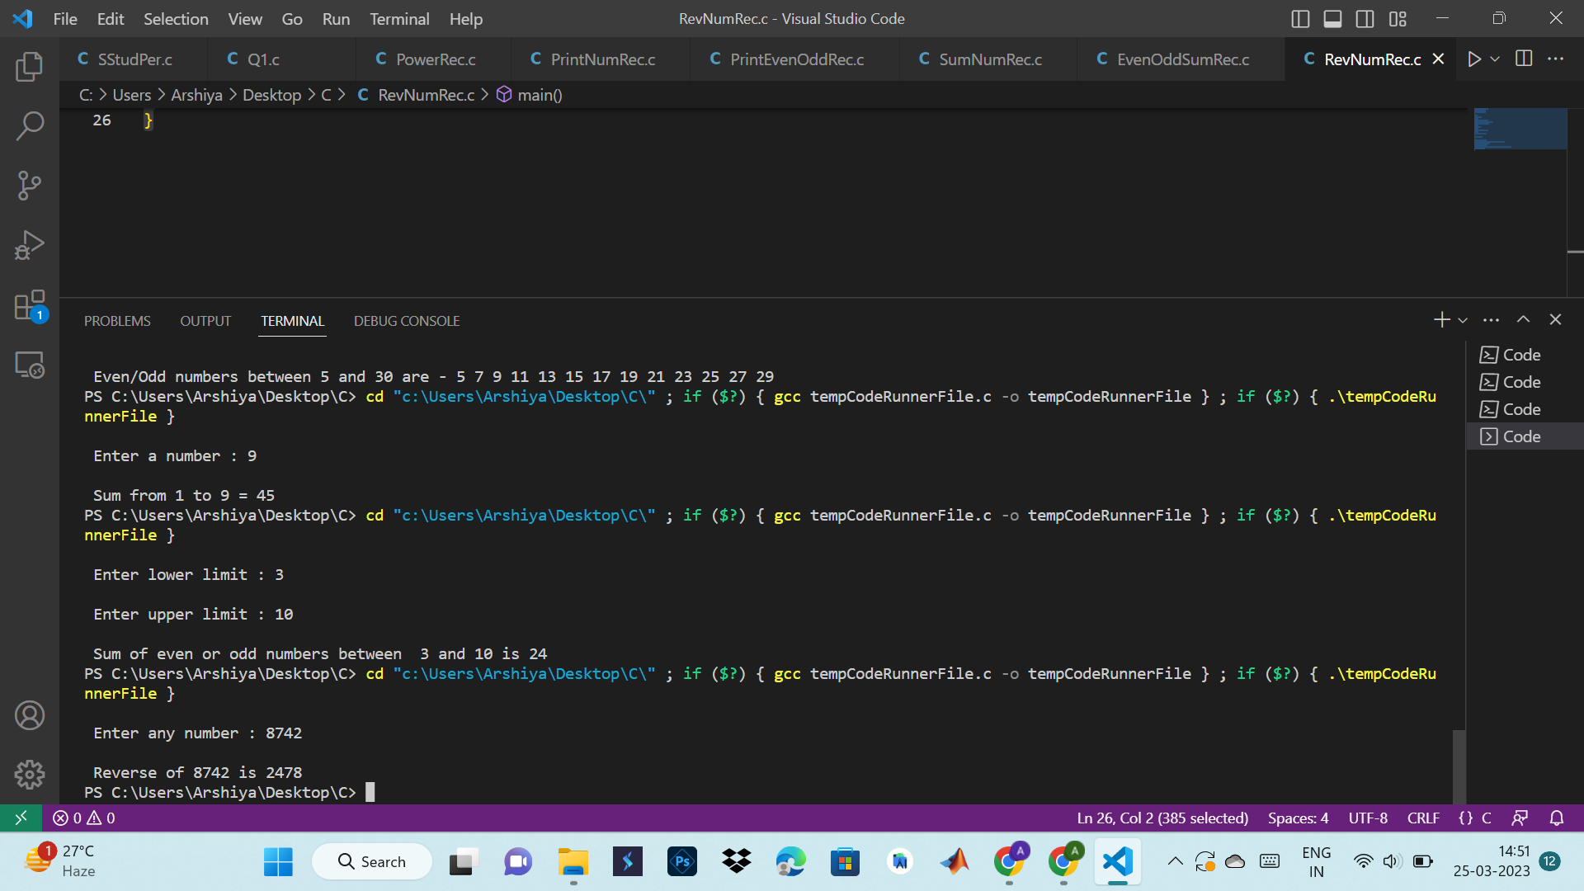

**20. Write a C program to find the reverse of any number using recursion.**

#include<stdio.h>

int rem,sum=0;

int rev(int n)

{

if(n)

{

rem=n%10;

sum=sum*10+rem;

rev(n/10);

}

else

{

return 0;

}

return sum;

}

int main()

{

int n,revn;

printf("\n Enter any number : ");

scanf("%d",&n);

revn=rev(n);

printf("\n Reverse of %d is %d ",n,revn);

return 0;

}



**21. Write a C program to reverse a sentence using recursion.**

#include<stdio.h>

void reverse()

{

char c;

scanf("%c",&c);

if(c!='\n')

{

reverse();

printf("%c",c);

}

}

int main()

{

printf("\n Enter a sentence : ");

reverse();

return 0;

}

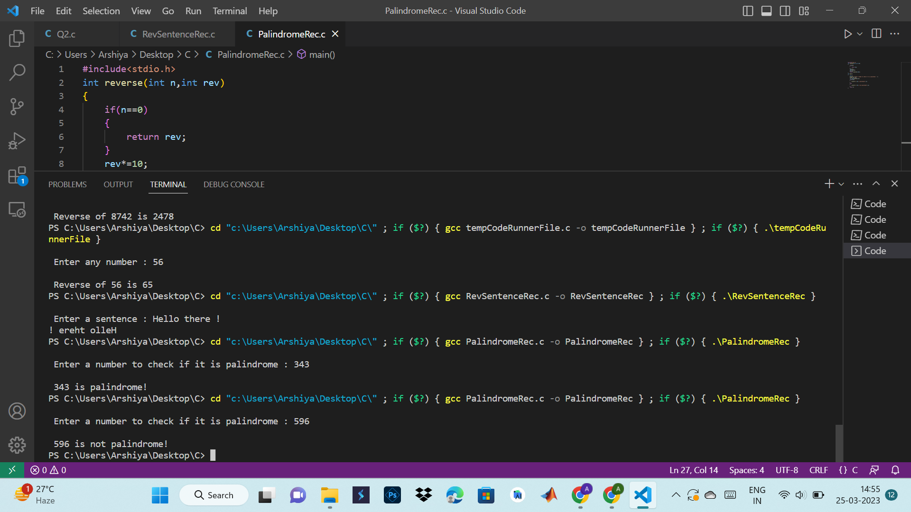

**22. Write a C program to check whether a number is a palindrome or not using recursion.**

#include<stdio.h>

int reverse(int n,int rev)

{

if(n==0)

{

return rev;

}

rev*=10;

rev+=(n%10);

n=n/10;

return reverse(n,rev);

}

int main()

{

int n;

printf("\n Enter a number to check if it is palindrome : ");

scanf("%d",&n);

int rev=reverse(n,0);

if(n==rev)

{

printf("\n %d is palindrome!",n);

}

else

{

printf("\n %d is not palindrome!",n);

}

return 0;

}



**23. Write a C program to find sum of digits of a given number using recursion.**

#include<stdio.h>

int sumdig(int n)

{

if(n==0)

return 0;

return ((n%10)+sumdig(n/10));

}

int main()

{

int n,sum;

printf("\n Enter a number : ");

scanf("%d",&n);

sum=sumdig(n);

printf("\n Sum of digits of %d is %d ",n,sum);

return 0;

}

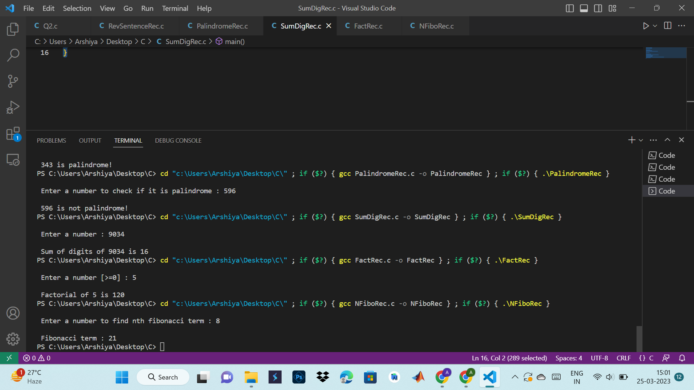

**24. Write a C program to find factorial of any number using recursion.**

#include<stdio.h>

int fact(int n)

{

if(n>=1)

return n*fact(n-1);

else

return 1;

}

int main()

{

int n;

printf("\n Enter a number [>=0] : ");

scanf("%d",&n);

printf("\n Factorial of %d is %d ",n,fact(n));

return 0;

}



**25. Write a C program to generate nth Fibonacci term using recursion.**

#include<stdio.h>

int fibo(int n)

{

if(n==0)

{

return 0;

}

else if(n==1)

{

return 1;

}

else

{

return fibo(n-1)+fibo(n-2);

}

}

int main()

{

int n,result;

printf("\n Enter a number to find nth fibonacci term : ");

scanf("%d",&n);

result=fibo(n);

printf("\n Fibonacci term : %d ",result);

return 0;

}



**26. Write a C program to find GCD (HCF) of two numbers using recursion.**

#include<stdio.h>

int gcd(int a, int b)

{

if(b==0)

return a;

else

return gcd(b,a%b);

}

int main()

{

int n1,n2,hcf;

printf("\n Enter num 1 : ");

scanf("%d",&n1);

printf("\n Enter num 2 : ");

scanf("%d",&n2);

hcf=gcd(n1,n2);

printf("\n GCD of %d and %d is %d ",n1,n2,hcf);

return 0;

}

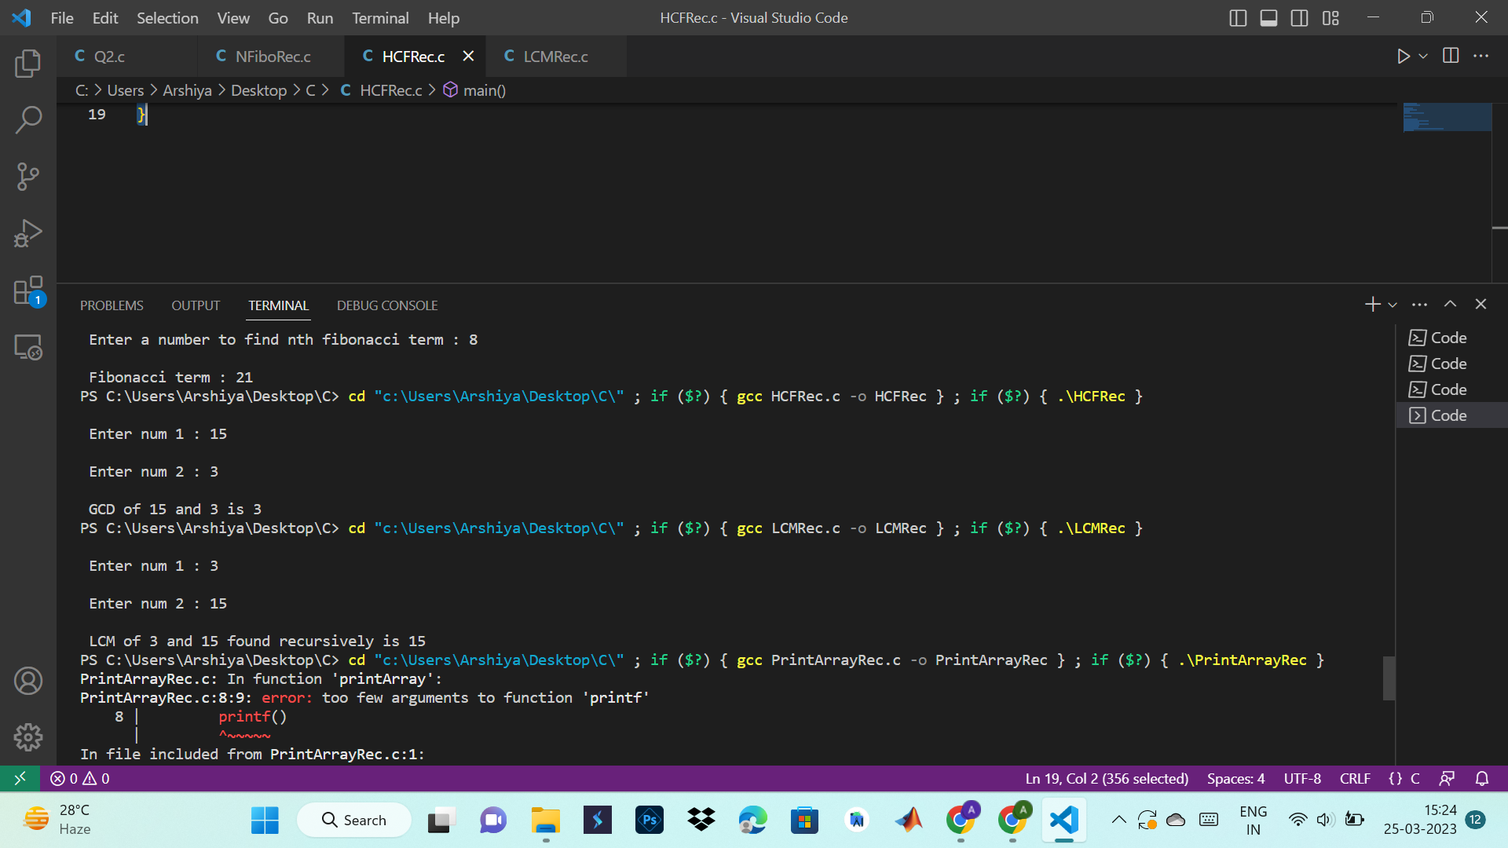

**27. Write a C program to find LCM of two numbers using recursion.**

#include<stdio.h>

int lcm(int a, int b)

{

static int c=1;

if(c%a==0 && c%b==0)

{

return c;

}

c++;

lcm(a,b);

}

int main()

{

int a,b,result;

printf("\n Enter num 1 : ");

scanf("%d",&a);

printf("\n Enter num 2 : ");

scanf("%d",&b);

result=lcm(a,b);

printf("\n LCM of %d and %d found recursively is %d ",a,b,result);

return 0;

}



**28. Write a C program to display all array elements using recursion.**

#include <stdio.h>

#define MAX_SIZE 100

void printArray(int arr[], int start, int len);

int main()

{

int arr[MAX_SIZE];

int N, i;

printf("Enter size of the array: ");

scanf("%d", &N);

printf("Enter elements in the array: ");

for(i=0; i<N; i++)

{

scanf("%d", &arr[i]);

}

printf("Elements in the array: ");

printArray(arr, 0, N);

return 0;

}

void printArray(int arr[], int start, int len)

{

if(start >= len)

return;

printf("%d, ", arr[start]);

printArray(arr, start + 1, len);

}

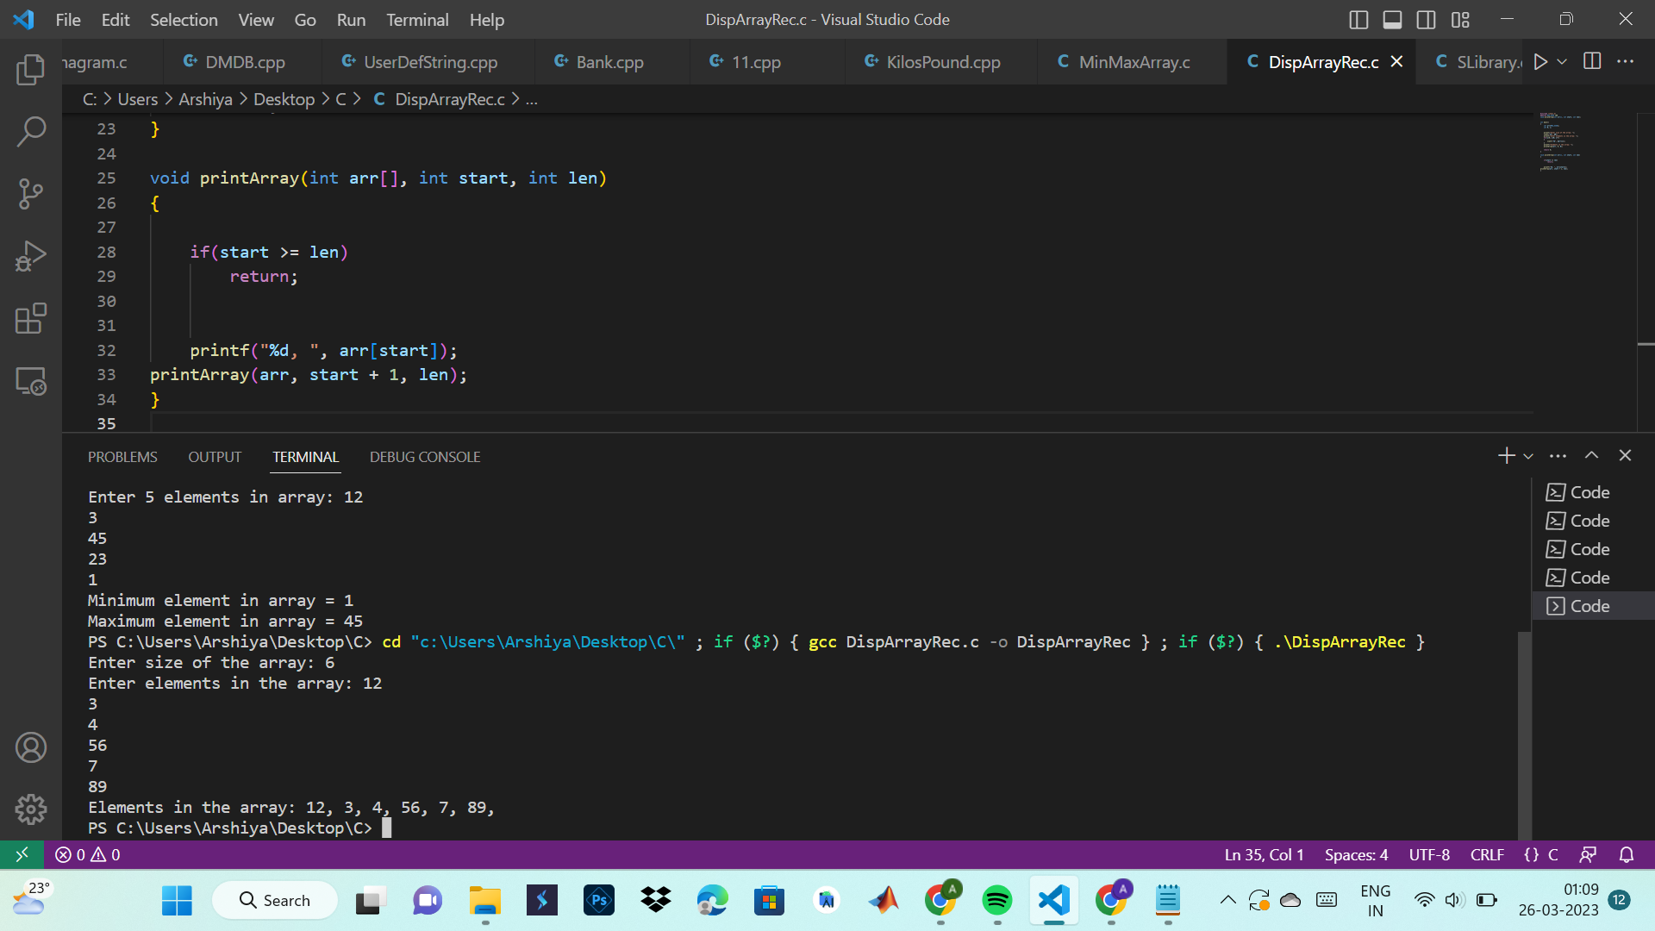

**29. Write a C program to find sum of elements of array using recursion.**

#include<stdio.h>

int findarrSum(int arr[], int n)

{

if(n<=0)

{

return 0;

}

return (findarrSum(arr,n-1)+arr[n-1]);

}

int main()

{

int arr[100], n,i;

printf("\n Enter the size of array : ");

scanf("%d",&n);

printf("\n Enter array elements : ");

for(i=0;i<n;i++)

{

printf("\n Enter element arr[%d] : ",i);

scanf("%d",&arr[i]);

}

printf("\n Sum of array : %d",findarrSum(arr,n));

return 0;

}

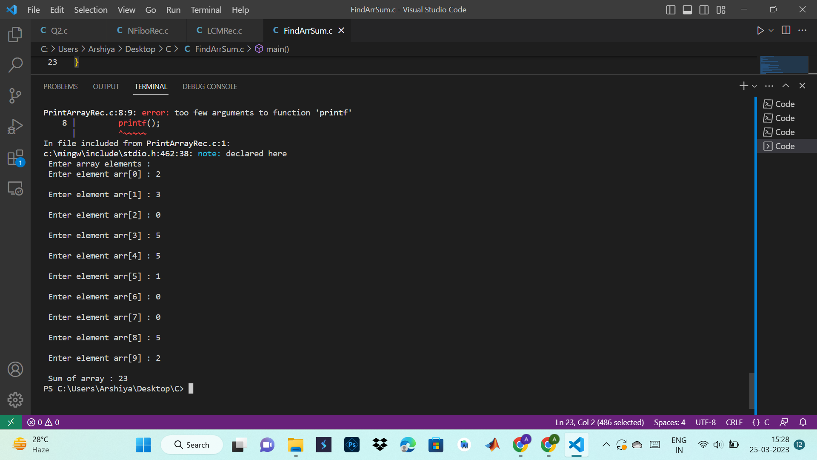

**30. Write a C program to find maximum and minimum elements in array using recursion.**

#include <stdio.h>

#define MAX_SIZE 100

int maximum(int array[], int index, int len);

int minimum(int array[], int index, int len);

int main()

{

int array[MAX_SIZE], N, max, min;

int i;

printf("Enter size of the array: ");

scanf("%d", &N);

printf("Enter %d elements in array: ", N);

for(i=0; i<N; i++)

{

scanf("%d", &array[i]);

}

max = maximum(array, 0, N);

min = minimum(array, 0, N);

printf("Minimum element in array = %d\n", min);

printf("Maximum element in array = %d\n", max);

return 0;

}

int maximum(int array[], int index, int len)

{

int max;

if(index >= len-2)

{

if(array[index] > array[index + 1])

return array[index];

else

return array[index + 1];

}

max = maximum(array, index + 1, len);

if(array[index] > max)

return array[index];

else

return max;

}

int minimum(int array[], int index, int len)

{

int min;

if(index >= len-2)

{

if(array[index] < array[index + 1])

return array[index];

else

return array[index + 1];

}

min = minimum(array, index + 1, len);

if(array[index] < min)

return array[index];

else

return min;

}

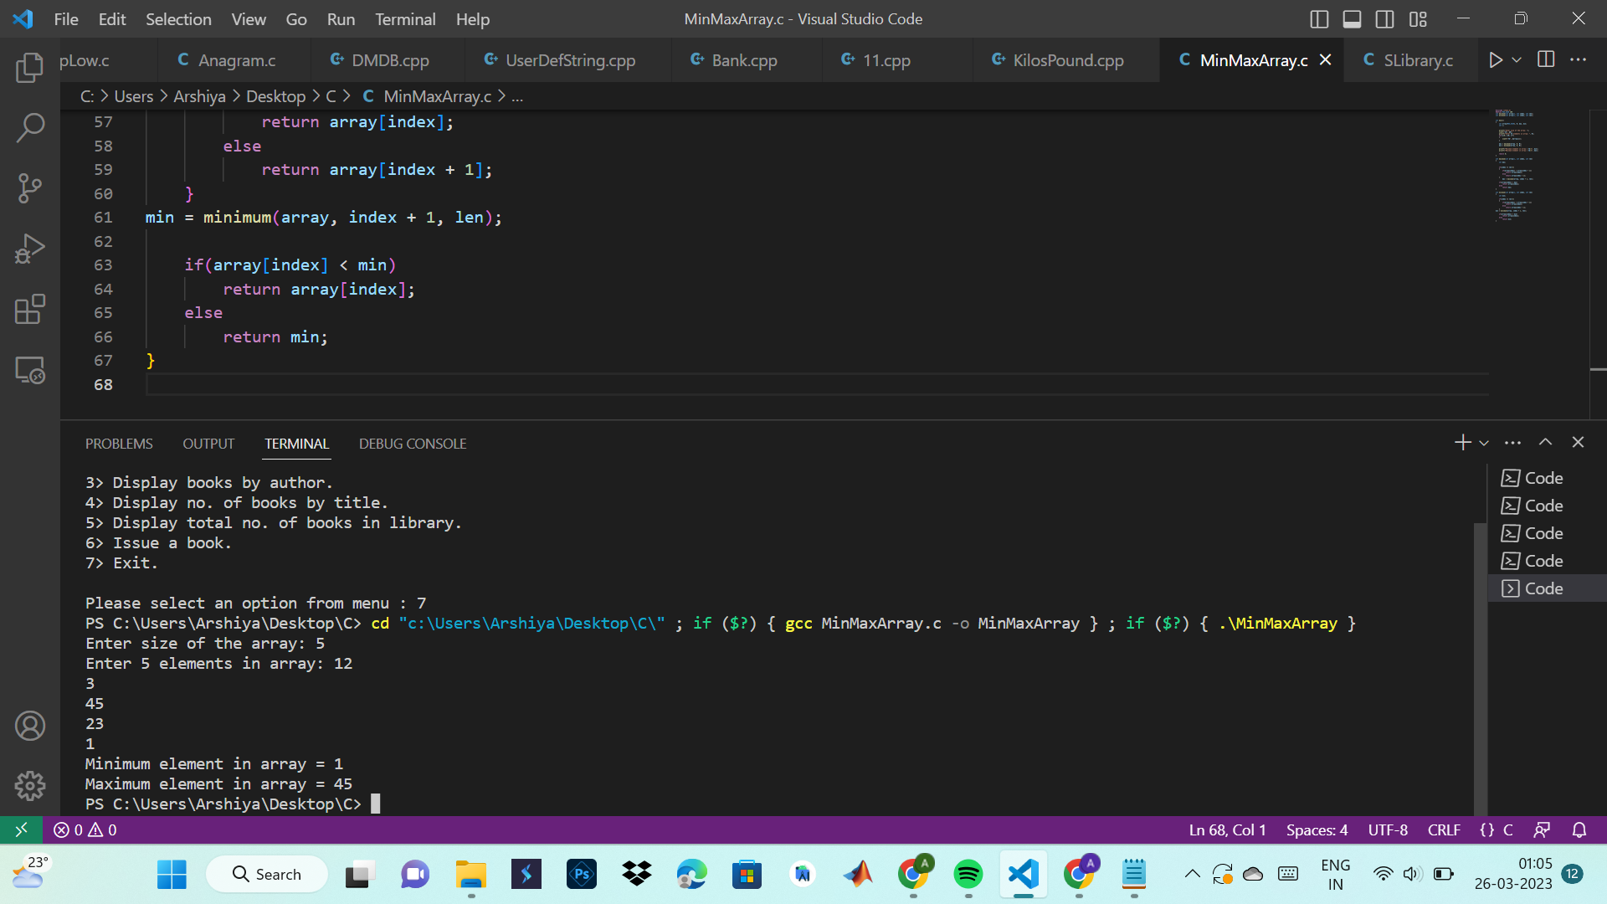

**STRINGS**

**1. String Copy**

#include<stdio.h>

#include<string.h>

int main()

{

char s1[100],s2[100];

int c=0;

printf("\n Enter a string to copy : ");

gets(s1);

printf("\n Enter destination string : ");

gets(s2);

while(s1[c]!='\0')

{

s2[c]=s1[c];

c++;

}

s2[c]='\0';

printf("\n After copying, the string is : %s ",s2);

return 0;

}

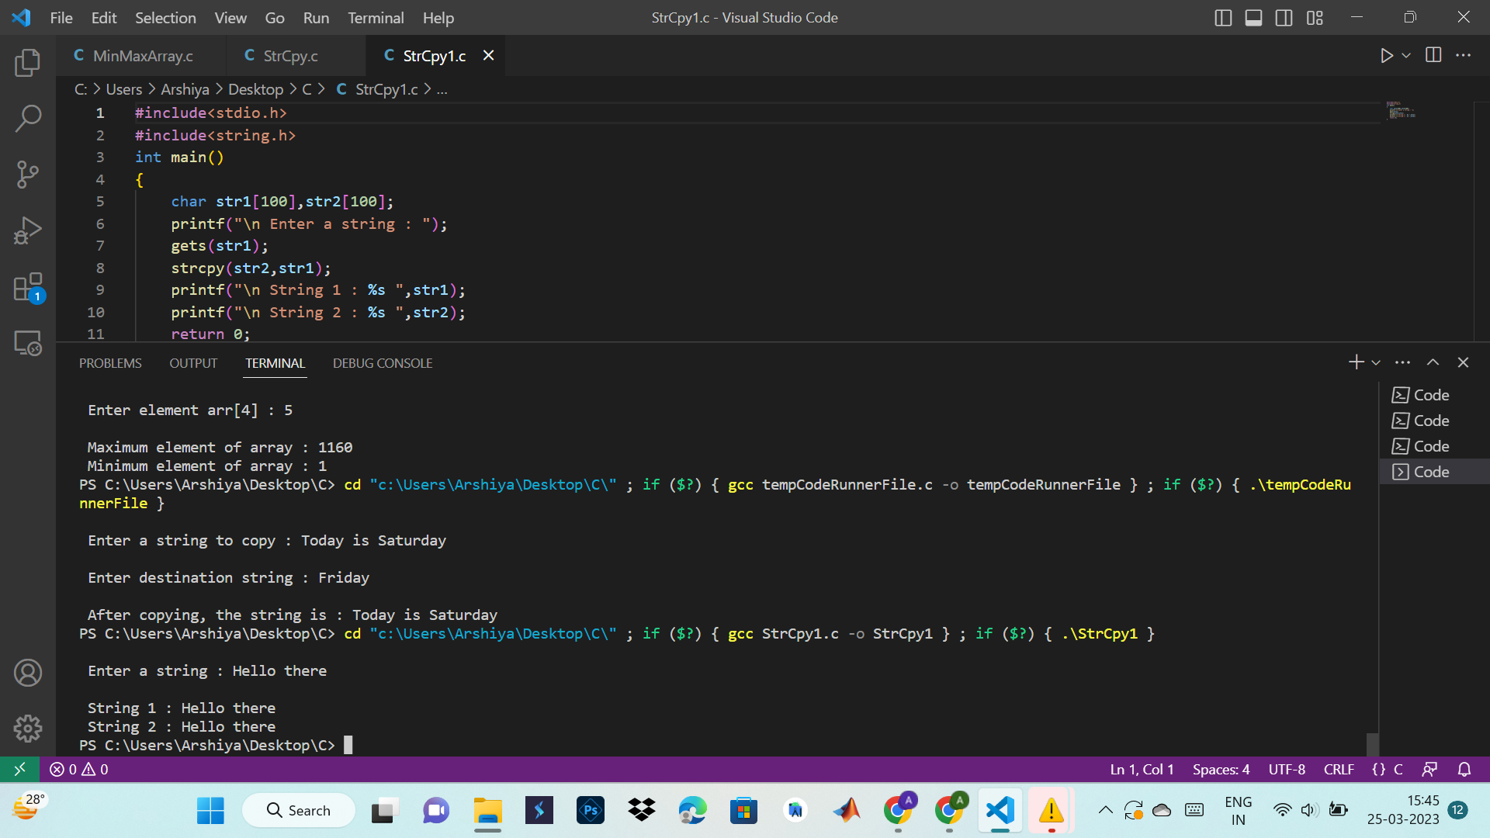

#include<stdio.h>

#include<string.h>

int main()

{

char str1[100],str2[100];

printf("\n Enter a string : ");

gets(str1);

strcpy(str2,str1);

printf("\n String 1 : %s ",str1);

printf("\n String 2 : %s ",str2);

return 0;

}



**2. String Compare**

#include<stdio.h>

#include<string.h>

int main()

{

char str1[100],str2[100];

int i=0;

printf("\n Enter the first string : ");

gets(str1);

printf("\n Enter the second string : ");

gets(str2);

for(i=0;str1[i]==str2[i] && str1[i]=='\0';i++);

if(str1[i]<str2[i])

{

printf("\n String 1 is less than String 2");

}

else if(str1[i]>str2[i])

{

printf("\n String 2 is less than String 1");

}

else

{

printf("\n String 1 and String 2 are same!");

}

return 0;

}

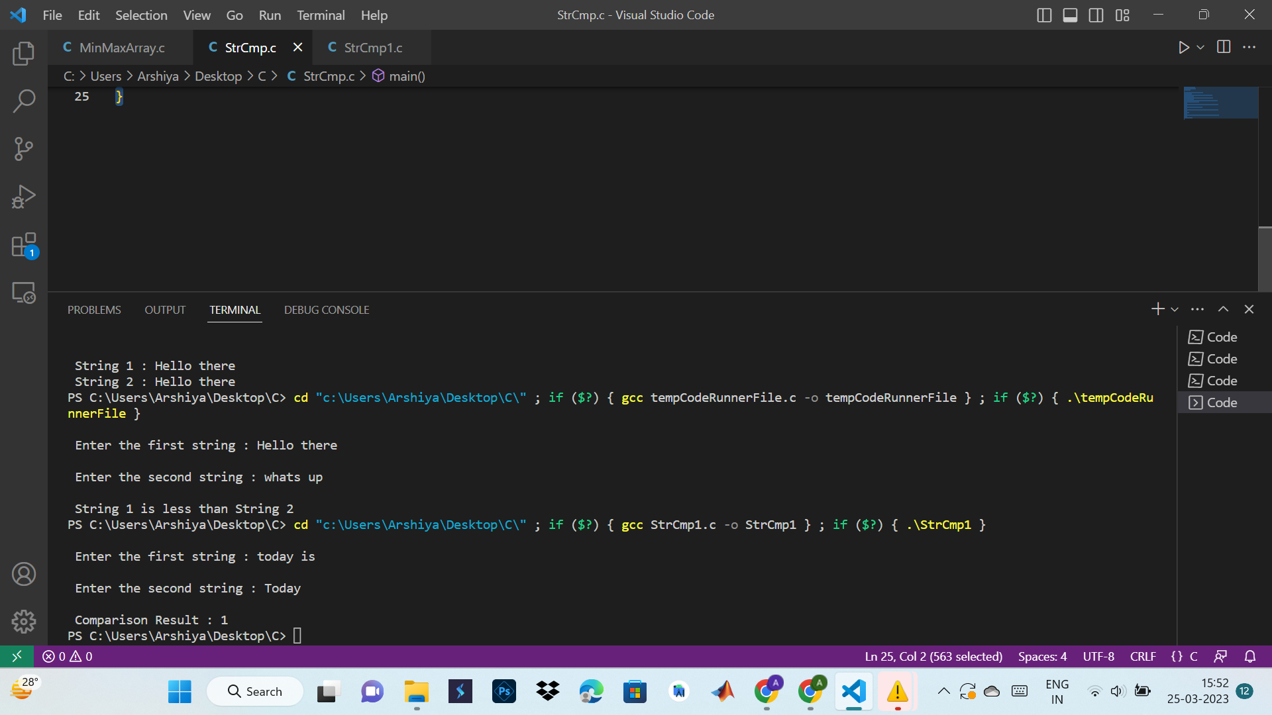

#include<stdio.h>

#include<string.h>

int main()

{

char str1[100],str2[100];

int i=0,result;

printf("\n Enter the first string : ");

gets(str1);

printf("\n Enter the second string : ");

gets(str2);

result=strcmp(str1,str2);

printf("\n Comparison Result : %d ",result);

return 0;

}



**3. String Length**

#include<stdio.h>

int main()

{

char str1[100];

int count=0;

printf("\n Enter string to check length : ");

gets(str1);

while(str1[count]!='\0')

{

count++;

}

printf("\n Length of string is : %d ",count);

return 0;

}

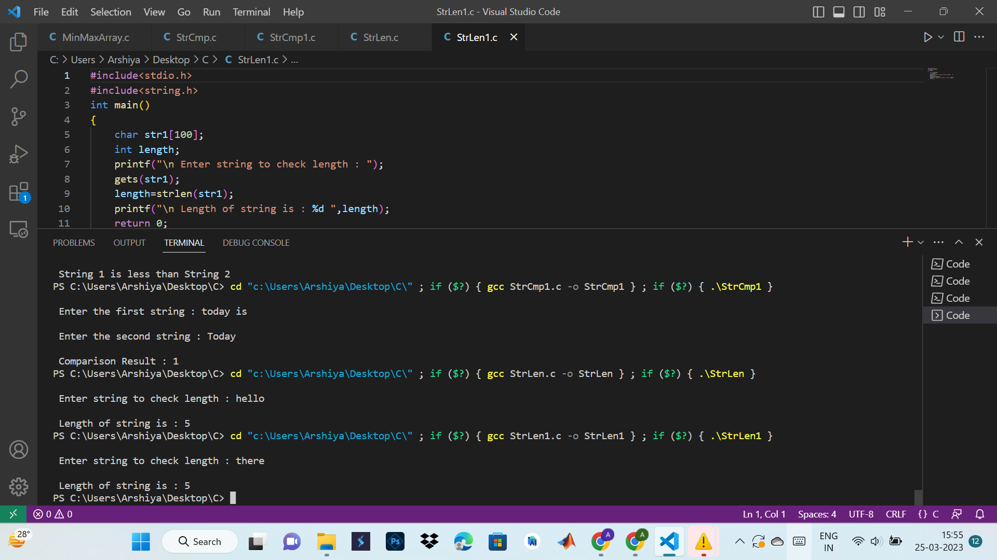

#include<stdio.h>

#include<string.h>

int main()

{

char str1[100];

int length;

printf("\n Enter string to check length : ");

gets(str1);

length=strlen(str1);

printf("\n Length of string is : %d ",length);

return 0;

}



**4. String Concatenate**

#include<stdio.h>

int main()

{

char str1[100],str2[100];

int len,i;

printf("\n Enter string 1 : ");

gets(str1);

printf("\n Enter string 2 : ");

gets(str2);

len=0;

while(str1[len]!='\0')

{

len++;

}

for(i=0;str2[i]!='\0';i++,len++)

{

str1[len]=str2[i];

}

str1[len]='\0';

printf("\n After Concatenation : ");

puts(str1);

}

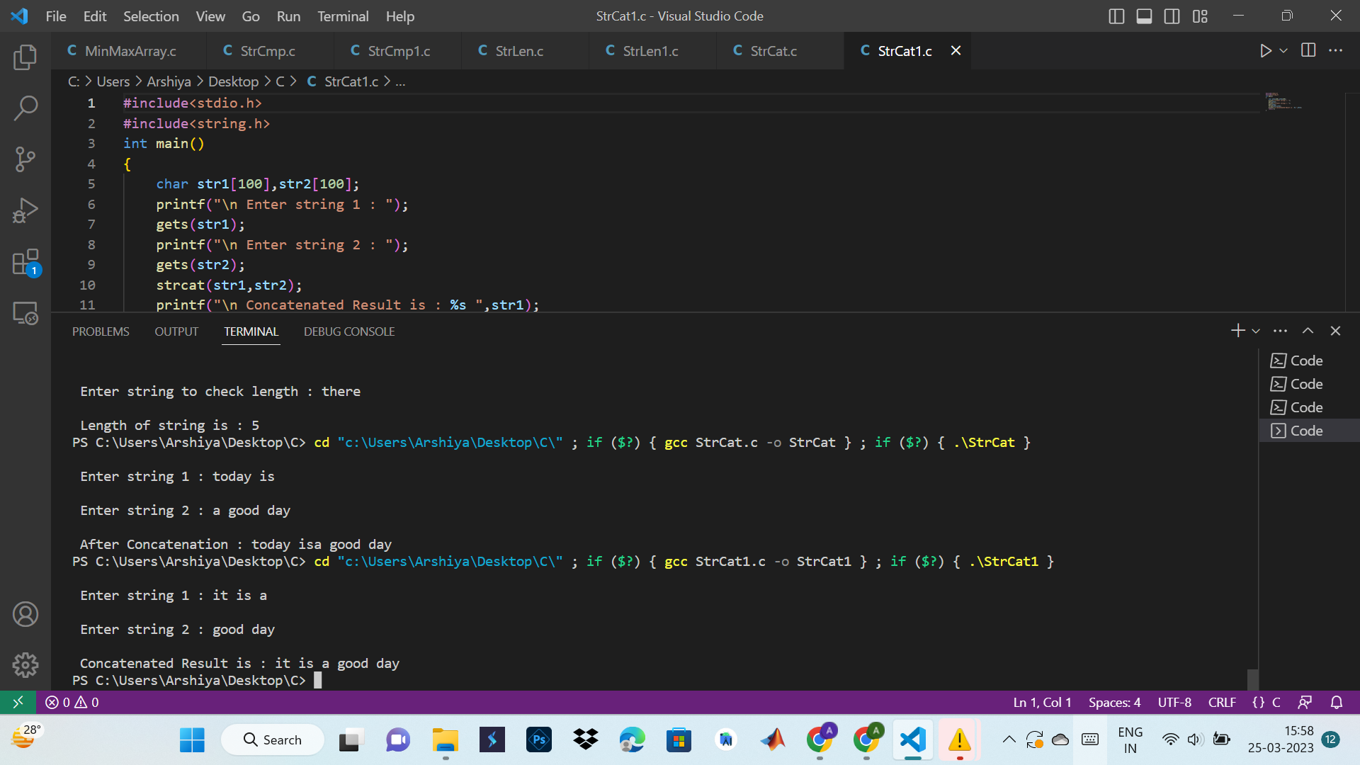

#include<stdio.h>

#include<string.h>

int main()

{

char str1[100],str2[100];

printf("\n Enter string 1 : ");

gets(str1);

printf("\n Enter string 2 : ");

gets(str2);

strcat(str1,str2);

printf("\n Concatenated Result is : %s ",str1);

return 0;

}



**STRUCTURE**

**1. Enter the marks of 5 students in Chemistry, Mathematics and Physics (each out of 100) using a**

**structure named Marks having elements roll no., name, chem_marks, maths_marks and**

**phy_marks and then display the percentage of each student.**

#include<stdio.h>

struct Marks

{

int roll_no;

char name[50];

int chem_marks,maths_marks,phy_marks;

};

int main()

{

struct Marks m[5];

for(int i=0;i<5;i++)

{

printf("\n Student %d ",i+1);

printf("\n Enter roll no. : ");

scanf("%d",&m[i].roll_no);

printf("\n Enter name : ");

scanf("%s",&m[i].name);

printf("\n Enter marks in chemistry : ");

scanf("%d",&m[i].chem_marks);

printf("\n Enter marks in maths : ");

scanf("%d",&m[i].maths_marks);

printf("\n Enter marks in physics : ");

scanf("%d",&m[i].phy_marks);

}

for(int i=0;i<5;i++)

{

printf("\n Student %d ",i+1);

float percentage = (m[i].chem_marks+m[i].maths_marks+m[i].phy_marks)/3;

printf("\n Percentage = %f ",percentage);

}

return 0;

}

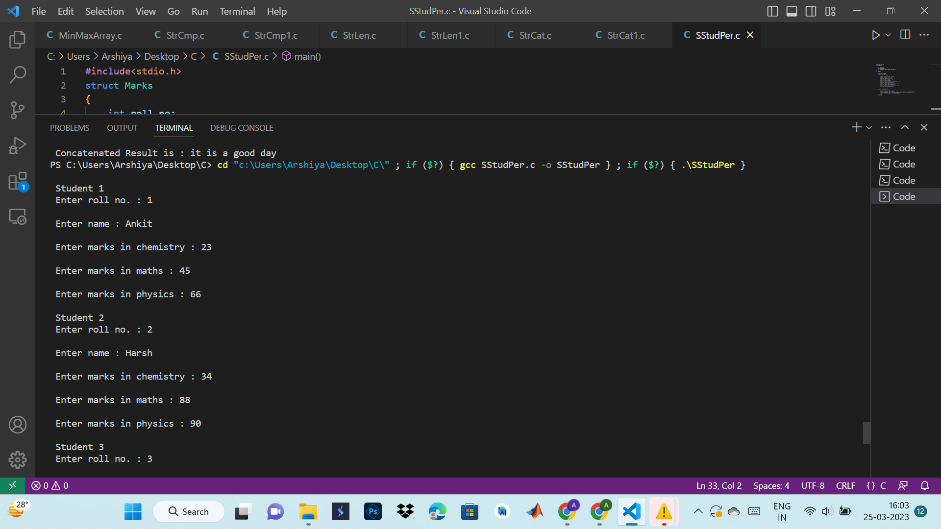

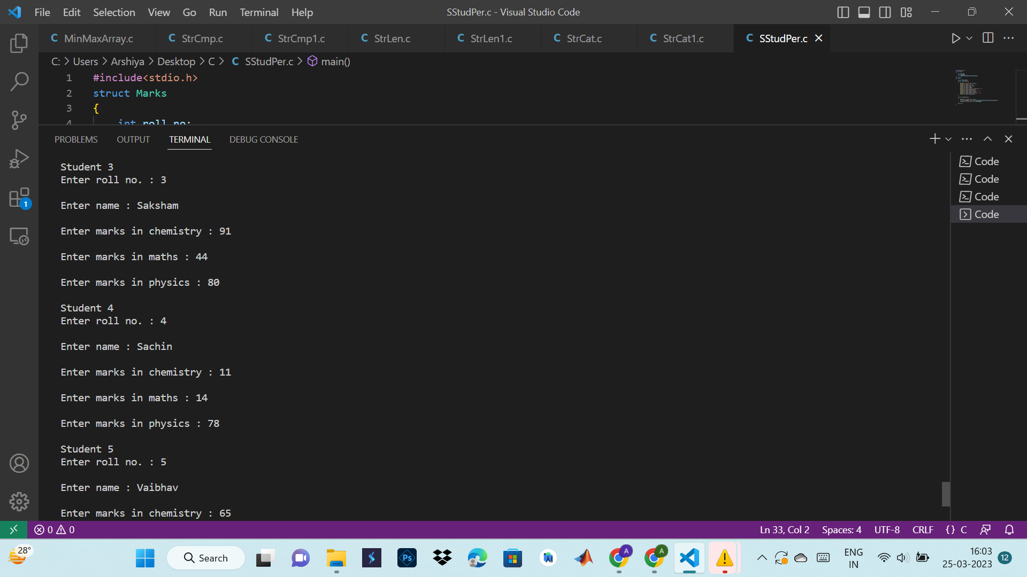

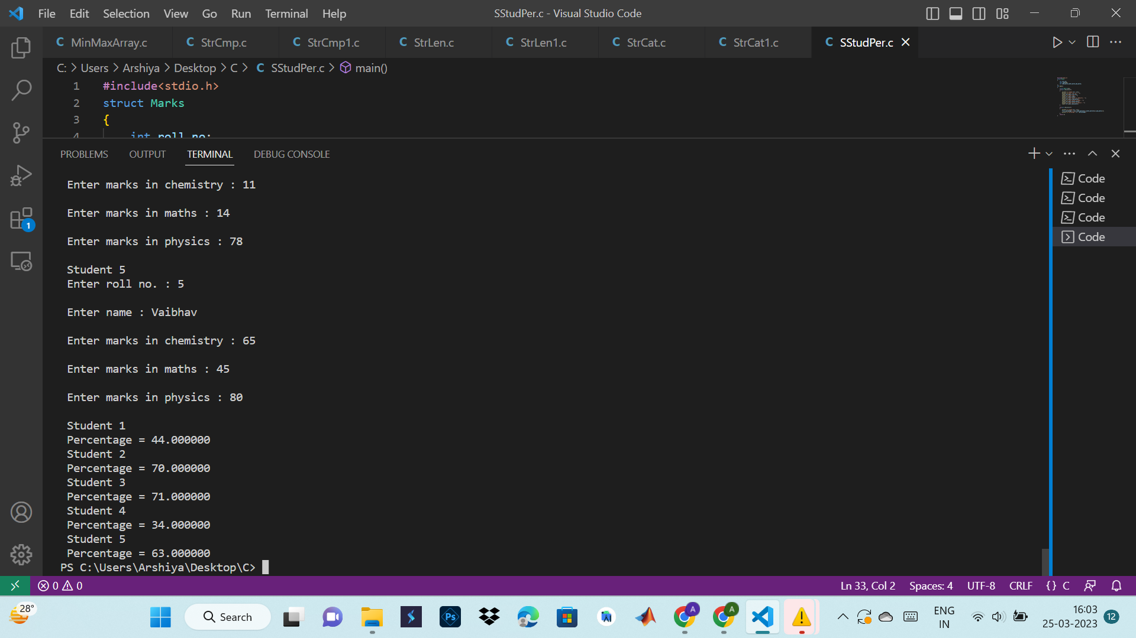

**2. Write a program to add, subtract and multiply two complex numbers using structures to**

**function.**

#include<stdio.h>

// Defining Structure :

struct complex{

float real;

float img;

};

// Main Function :

int main(){

struct complex a, b, res , add, sub ;

printf("Enter the Real and Imaginary part of first complex number : \n");

scanf("%f%f",&a.real,&a.img);

printf("Enter the Real and Imaginary part of Second complex number : \n");

scanf("%f%f",&b.real,&b.img);

// Addition :

add.real = a.real+b.real;

add.img = a.img+b.img;

printf("Addition = %0.2f + i %0.2f\n",add.real,add.img);

// Substraction :

sub.real = a.real-b.real;

sub.img = a.img-b.img;

printf("Subtraction = %0.2f + i %0.2f\n",sub.real,sub.img);

//Multiplication :

res.real=(a.real*b.real-a.img*b.img);

res.img = (a.real*b.img+a.img*b.real);

printf("Multiplication = %0.2f + i %0.2f\n ",res.real,res.img);

return 0;

}

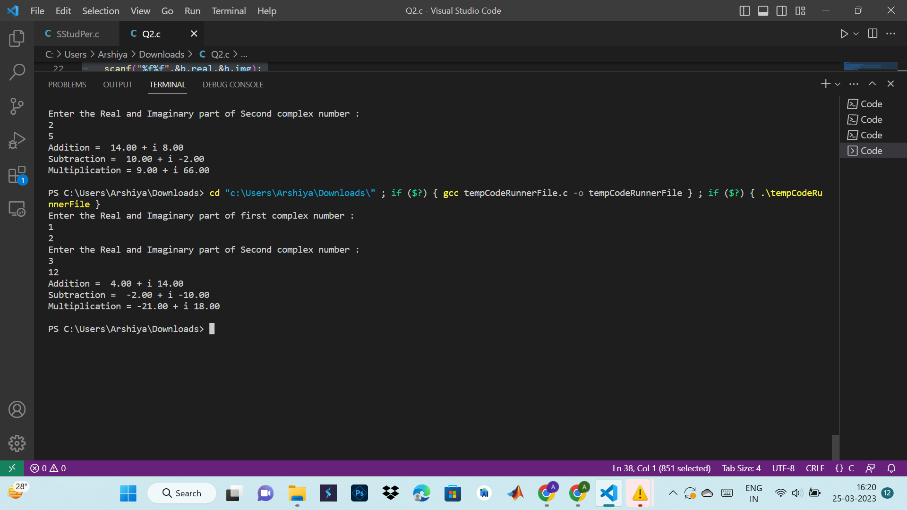

**3. Write a structure to store the roll no., name, age (between 11 to 14) and address of students**

**(more than 10). Store the information of the students.**

**1 - Write a function to print the names of all the students having age 14.**

**2 - Write another function to print the names of all the students having even roll no.**

**3 - Write another function to display the details of the student whose roll no is given (i.e., roll**

**no. entered by the user).**

#include<stdio.h>

// Defining Structure :

struct Student {

int roll_no;

int age;

char name[30];

char address[100];

};

// Function to print the names of all the students having age 14.

void checkAge( struct Student student[],int n){

int i;

printf("Students whose age is 14\n");

for(i=0;i<n;i++)

{

if(student[i].age==14)

printf("Name : %s\n",student[i].name);

printf("---------------------------------------\n");

}

}

// Function to print the names of all the students having even roll no.

void checkRoll(struct Student student[],int n){

int i;

printf("Students with Even Roll No.\n");

for(i=0;i<n;i++)

{

if(student[i].roll_no%2==0)

printf("Name : %s\n",student[i].name);

}

}

//Function to display the details of the student whose roll no is given (i.e. roll no. entered by the user).

void details( struct Student student[], int n){

printf("Enter Roll No. : \n");

int roll,i;

scanf("%d",&roll);

printf(" Student Details of given roll No:");

for(i=0;i<n;i++)

{

if(student[i].roll_no==roll)

{

printf("Roll No. : %d\n",student[i].roll_no);

printf("Name : %s\n",student[i].name);

printf("Name : %d\n",student[i].age);

printf("Name : %s\n",student[i].address);

}

}

}

// Main Function :

int main(){

int n, i;

printf("Enter Number of Students : ");

scanf("%d",&n);

struct Student student[n];

for(i=0;i<n;i++){

printf("Student %d\n",i+1);

printf("Enter Roll No. :\n");

scanf("%d",&student[i].roll_no);

printf("Enter Name of Student :\n");

scanf("%s",&student[i].name);

printf("Enter Age of Student :\n");

scanf("%d",&student[i].age);

printf("Enter Address of Student :\n ");

scanf("%s",&student[i].address);

}

checkAge(student,n);

checkRoll(student,n);

details(student,n);

return 0;

}

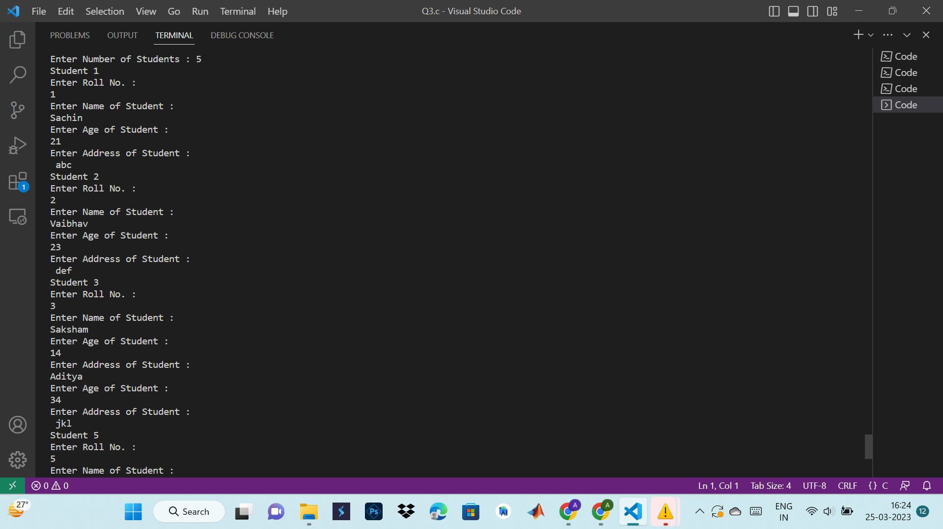

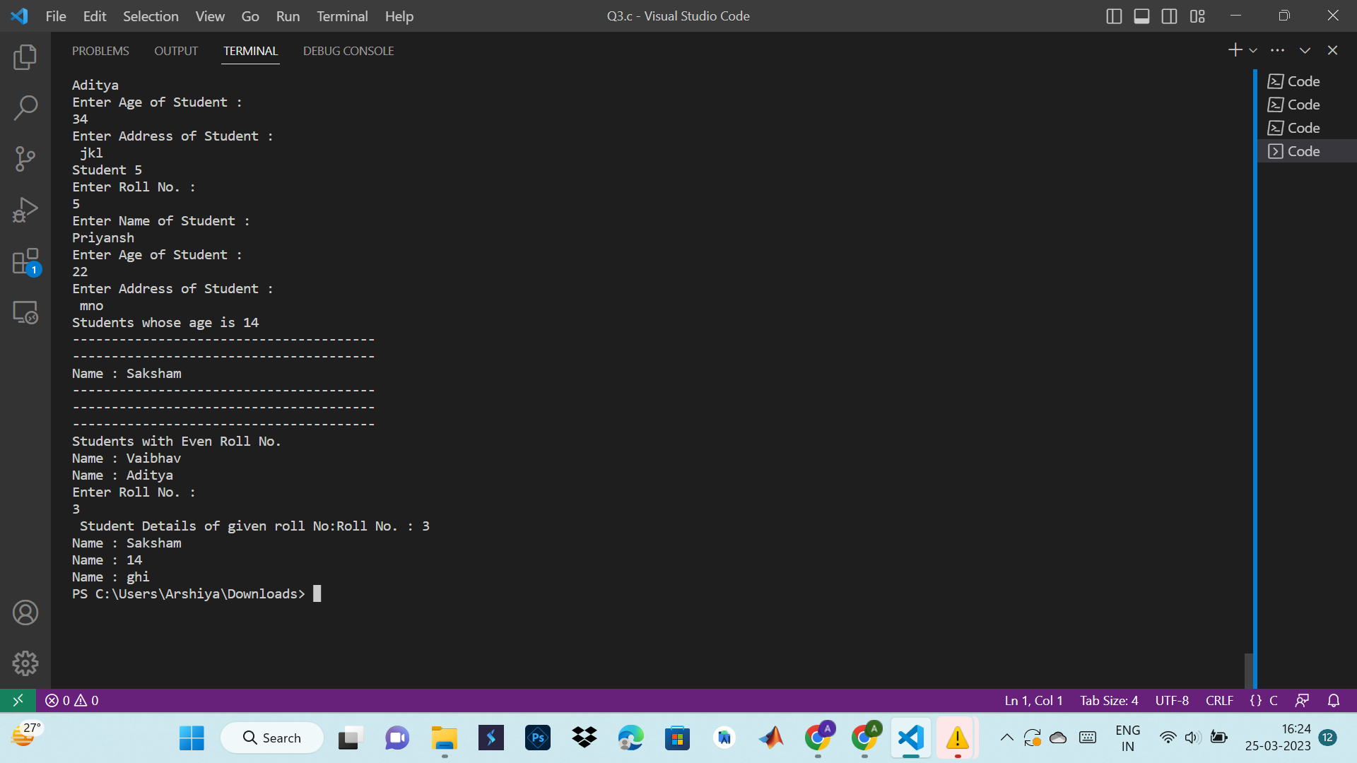

**4. Write a structure to store the name, account number and balance of customers (more than 10)**

**and store their information.**

**1 - Write a function to print the names of all the customers having a balance of less than $200.**

**2 - Write a function to add $100 to the balance of all the customers having more than $1000 in**

**their balance and then print the incremented value of their balance.**

#include<stdio.h>

//Defining Structure of program :

struct Bank{

int acc_no;

char name[30];

float bal;

}b[10];

// 1. Write a function to print the names of all the customers having a balance of less than $200.

void check(struct Bank b[10], int n)

{

int i;

printf("\nCustomer's Balance Whose Balance is < $200\n");

printf("----------------------------------------\n");

for(i=0;i<n;i++)

{

if(b[i].bal<200)

{

printf("Account Number : %d\n",b[i].acc_no);

printf("Name : %s\n",b[i].name);

printf("Balance : %f\n",b[i].bal);

printf("------------------------------\n");

}

}

}

/* 2. Write a function to add $100 to the balance of all the customers having more than $1000 in

their balance and then print the incremented value of their balance.*/

int update( struct Bank b[],int n)

{

int i;

for ( i=0;i<n;i++)

{

if (b[i].bal>=1000)

{

printf("Customer's Balance Whose balance is > $1000 %d\n",i+1);

printf("Account Number : %d\n",b[i].acc_no);

printf("Name : %s\n",b[i].name);

printf("Balance $ : %f\n",b[i].bal);

printf("Update Balance $ : %f\n,",b[i].bal+100);

printf("------------------------------\n");

}

}

}

// Main Function :

int main(){

int i;

for(i=0;i<10;i++)

{

printf("Enter the detail of the Customer %d\n",i+1);

printf("------------------------------\n");

printf("Enter Account Number : ");

scanf("%d",&b[i].acc_no);

printf("Enter the Customer Name : ");

scanf("%s",&b[i].name);

printf("Enter the balance of the Customer : ");

scanf("%f",&b[i].bal);

printf("------------------------------\n");

}

check(b,10);

update(b,10);

return 0;

}

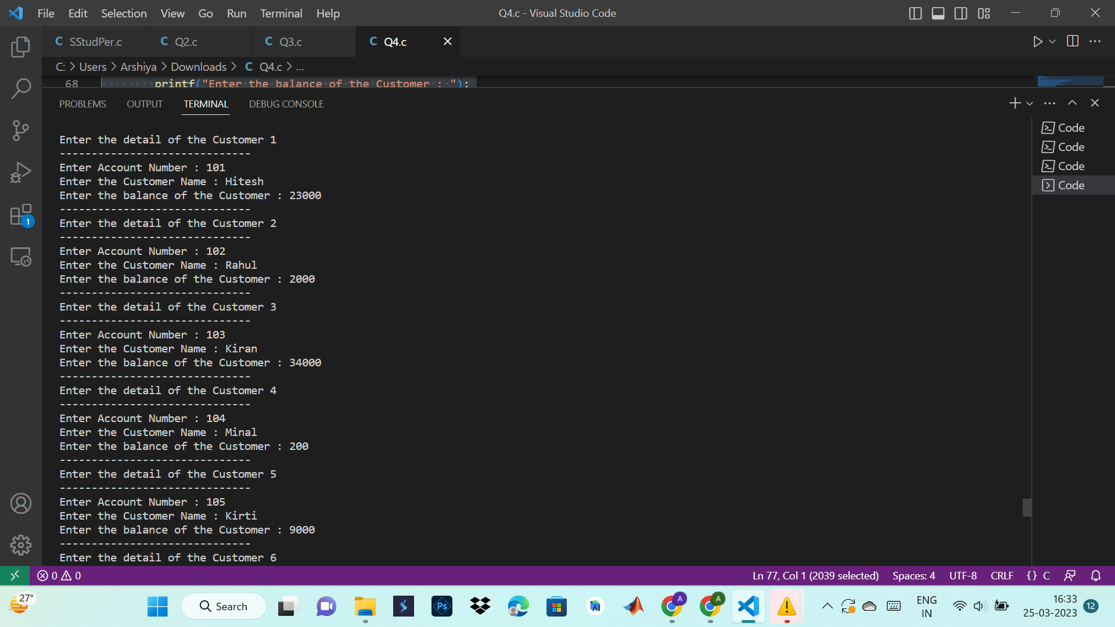

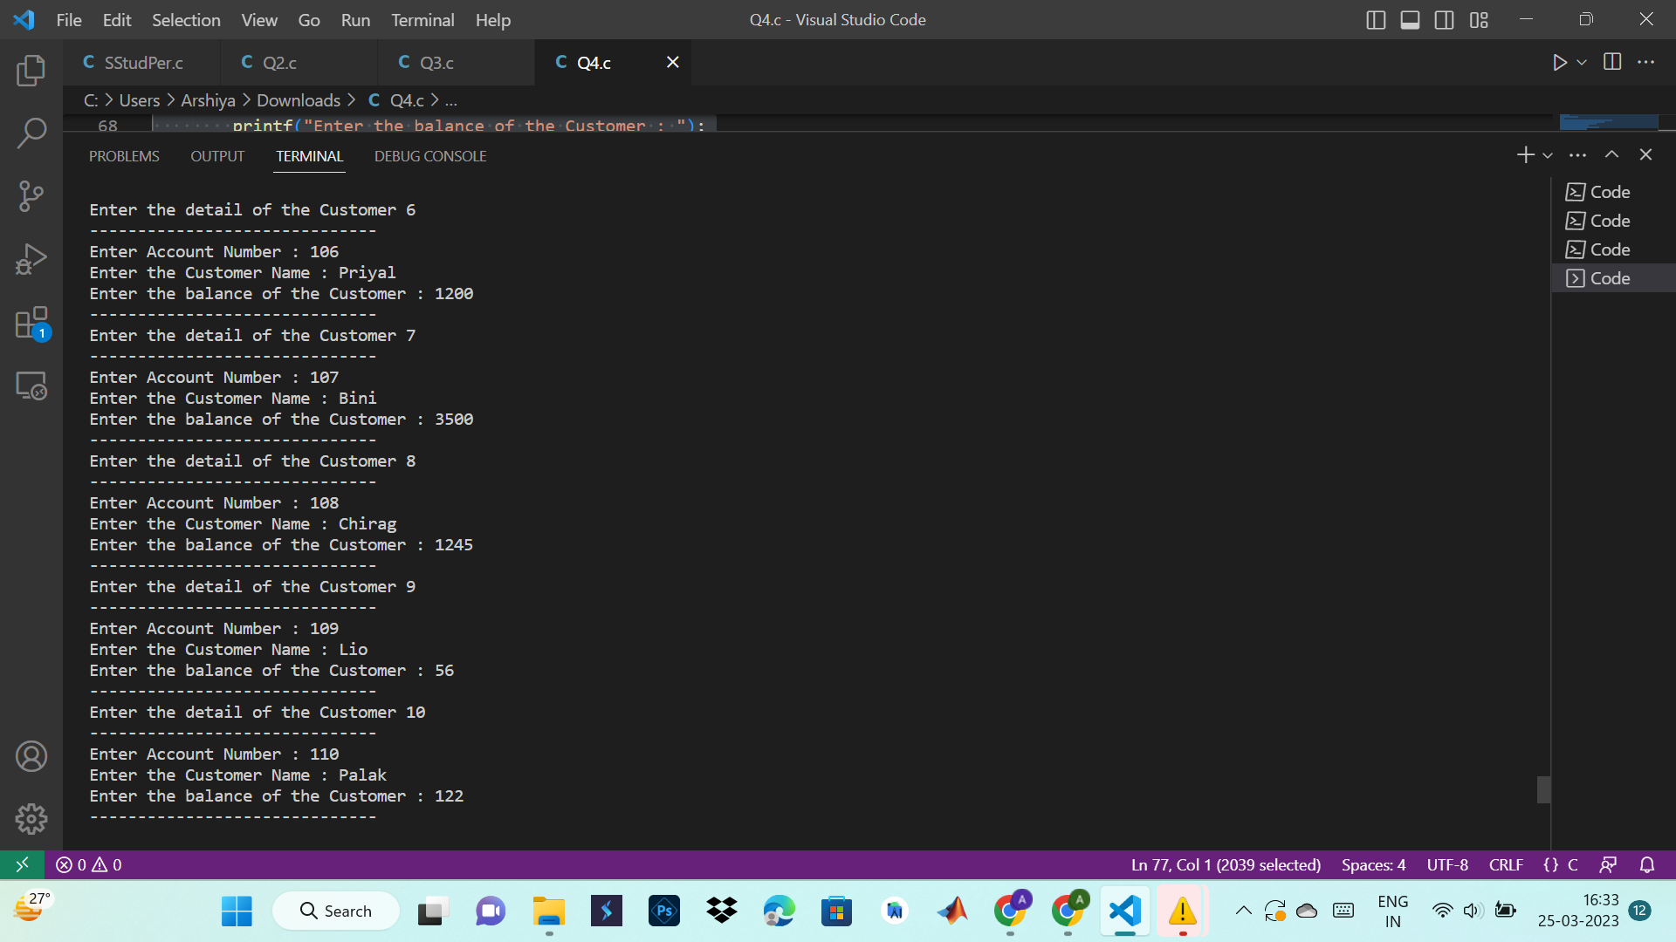

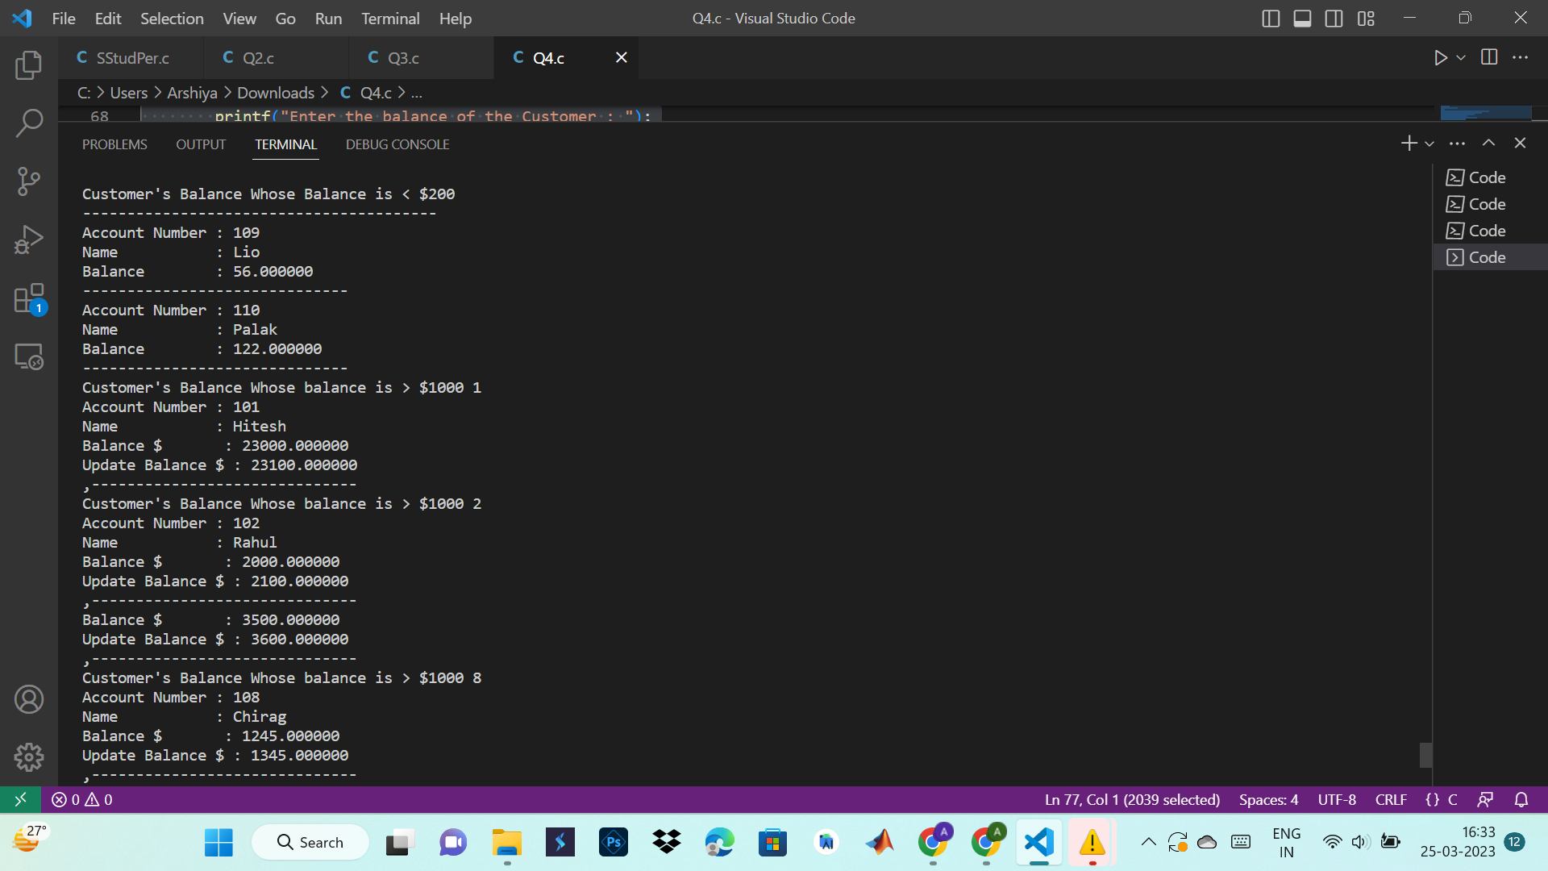

**5. Let us work on the menu of a library. Create a structure containing book information like**

**accession number, name of author, book title and flag to know whether book is issued or not.**

**Create a menu in which the following can be done.**

**1 - Display book information**

**2 - Add a new book**

**3 - Display all the books in the library of a particular author**

**4 - Display the number of books of a particular title**

**5 - Display the total number of books in the library**

**6 - Issue a book (If we issue a book, then its number gets decreased by 1 and if we add a book,**

**its number gets increased by 1)**

#include<stdio.h>

#include<string.h> //for strcmp()

#include<stdlib.h> //for system("cls") {works in dev c++}

int total_books = 0;

int current_books_count = 0;

struct library

{

int accession_number;

char author[50];

char title[50];

int issue_flag; // 0 => Available | 1 => Issued

}

book[200];

int display_book_info()

{

int i=0,book_no=0,found_flag = 0;

printf("Please enter accession_number : ");

scanf("%d",&book_no);

for(i=0 ; i < total_books ; i++)

{

if(book[i].accession_number == book_no)

{

printf("\n\tAccession no : %d",book[i].accession_number);

printf("\n\tAuthor : %s",book[i].author);

printf("\tTitle : %s",book[i].title);

printf("\tStatus : ");

if(book[i].issue_flag)

printf("Issued\n");

else

printf("Available\n");

found_flag = 1;

break;

}

}

if(!found_flag)

{

printf("\nNo book found with accession no. : %d\n",book_no);

i = -1;

}

return i;

}

void add_new_book()

{

printf("\nPlease enter accession no. : ");

fflush(stdin);

scanf("%d",& book[total_books].accession_number);

printf("Please enter name of the Author : ");

fflush(stdin);

fgets(book[total_books].author, sizeof(book[total_books].author),stdin);

printf("Please enter book title : ");

fflush(stdin);

fgets(book[total_books].title, sizeof(book[total_books].title),stdin);

book[total_books].issue_flag = 0;

total_books++;

current_books_count++;

}

int disp_by_author()

{

int i=0,found_flag = 0;

char author[50];

printf("Please enter name of the author : ");

fflush(stdin);

fgets(author, sizeof(author),stdin);

for(i=0 ; i < total_books ; i++)

{

if(!strcmp(book[i].author,author))

{

printf("\n\tAccession no. : %d", book[i].accession_number);

printf("\n\tAuthor : %s",book[i].author);

printf("\tTitle : %s",book[i].title);

printf("\tStatus : ");

if(book[i].issue_flag)

printf("Issued\n");

else

printf("Available\n");

found_flag = 1;

break;

}

}

if(!found_flag)

{

printf("\nNo book found with Author name : %s",author);

i = -1;

}

return i;

}

int disp_by_title()

{

int i=0,found_flag = 0;

char title[50];

printf("Please enter book title : ");

fflush(stdin);

fgets(title, sizeof(title),stdin);

for(i=0 ; i < total_books ; i++)

{

if(!strcmp(book[i].title,title))

{

printf("\n\tAccession no. : %d", book[i].accession_number);

printf("\n\tAuthor : %s",book[i].author);

printf("\tTitle : %s",book[i].title);

printf("\tStatus : ");

if(book[i].issue_flag)

printf("Issued\n");

else

printf("Available\n");

found_flag = 1;

break;

}

}

if(!found_flag)

{

printf("\nNo book found with book title : %s",title);

i = -1;

}

return i;

}

int issue_book()

{

int i,search_num=0, choice=0,found_flag = 0;

char search_quary[50],issue_choice;

again:

printf("\nSearch book by : ");

printf("\n1> Title.");

printf("\n2> Author.");

printf("\n3> Accession no.");

printf("\n4> Back to menu.\n");

printf("\nPlease enter your choice : ");

scanf("%d",&choice);

switch(choice)

{

case 1:

i = disp_by_title();

break;

case 2:

i = disp_by_author();

break;

case 3:

i = display_book_info();

break;

case 4:

return 0;

default:

{

printf("Please enter valid choice.");

goto again;

}

}

if (i >= 0)

found_flag = 1;

if(found_flag)

{

if(book[i].issue_flag)

printf("\nSorry book is issued.\n");

else

{

fflush(stdin);

printf("\nDo you want to issue this book (Y/N) : ");

scanf("%c",& issue_choice);

if(issue_choice == 'Y' || issue_choice == 'y')

{

book[i].issue_flag = 1;

current_books_count--;

printf("\nBook issued Successfully.");

}

}

}

else

{

printf("\nNo record found with given quary.");

goto again;

}

}

int main()

{

int choice;

char next;

while(1)

{

system("cls");

printf("________MENU________");

printf("\n1> Display book information.");

printf("\n2> Add a new book.");

printf("\n3> Display books by author.");

printf("\n4> Display no. of books by title.");

printf("\n5> Display total no. of books in library.");

printf("\n6> Issue a book.");

printf("\n7> Exit.\n");

printf("\nPlease select an option from menu : ");

scanf("%d",& choice);

switch(choice)

{

case 1:

display_book_info();

break;

case 2:

add_new_book();

break;

case 3:

disp_by_author();

break;

case 4:

disp_by_title();

break;

case 5:

printf("\nTotal no. of books currently in library : %d\n",current_books_count);

break;

case 6:

issue_book();

break;

case 7:

exit(0);

break;

default:

printf("\nPlease select a valid option from menu.\n\n");

}

printf("\nFor next press enter : ");

fflush(stdin);

scanf("%c",& next);

}

return 0;

}

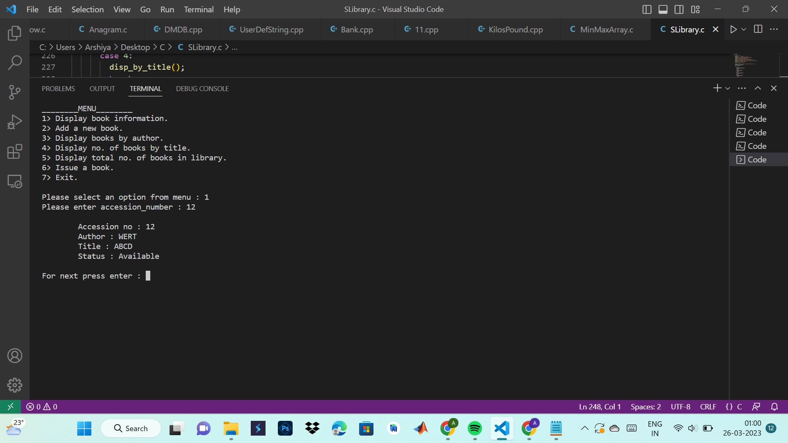

**CLASSES AND FILES**

**1. Write a C++ program to get and display the details of staff name and designation in a class, department, salary in another class, and awards in the third class using Inheritance.**

#include <iostream>

#include <string>

using namespace std;

class Staff {

protected:

string name;

string designation;

public:

void getDetails() {

cout << "Enter the name of the staff member: ";

getline(cin, name);

cout << "Enter the designation of the staff member: ";

getline(cin, designation);

}

void displayDetails() {

cout << "Name: " << name << endl;

cout << "Designation: " << designation << endl;

}

};

class Department : public Staff {

protected:

string department;

public:

void getDepartment() {

cout << "Enter the department name: ";

getline(cin, department);

}

void displayDepartment() {

cout << "Department: " << department << endl;

}

};

class Salary : public Staff {

protected:

float salary;

public:

void getSalary() {

cout << "Enter the salary: ";

cin >> salary;

}

void displaySalary() {

cout << "Salary: " << salary << endl;

}

};

class Award : public Staff {

protected:

string award;

public:

void getAward() {

cout << "Enter the award: ";

getline(cin, award);

}

void displayAward() {

cout << "Award: " << award << endl;

}

};

int main() {

Department d;

d.getDetails();

d.getDepartment();

cout << endl;

d.displayDetails();

d.displayDepartment();

cout << endl;

Salary s;

s.getDetails();

s.getSalary();

cout << endl;

s.displayDetails();

s.displaySalary();

cout << endl;

Award a;

a.getDetails();

a.getAward();

cout << endl;

a.displayDetails();

a.displayAward();

cout << endl;

return 0;

}

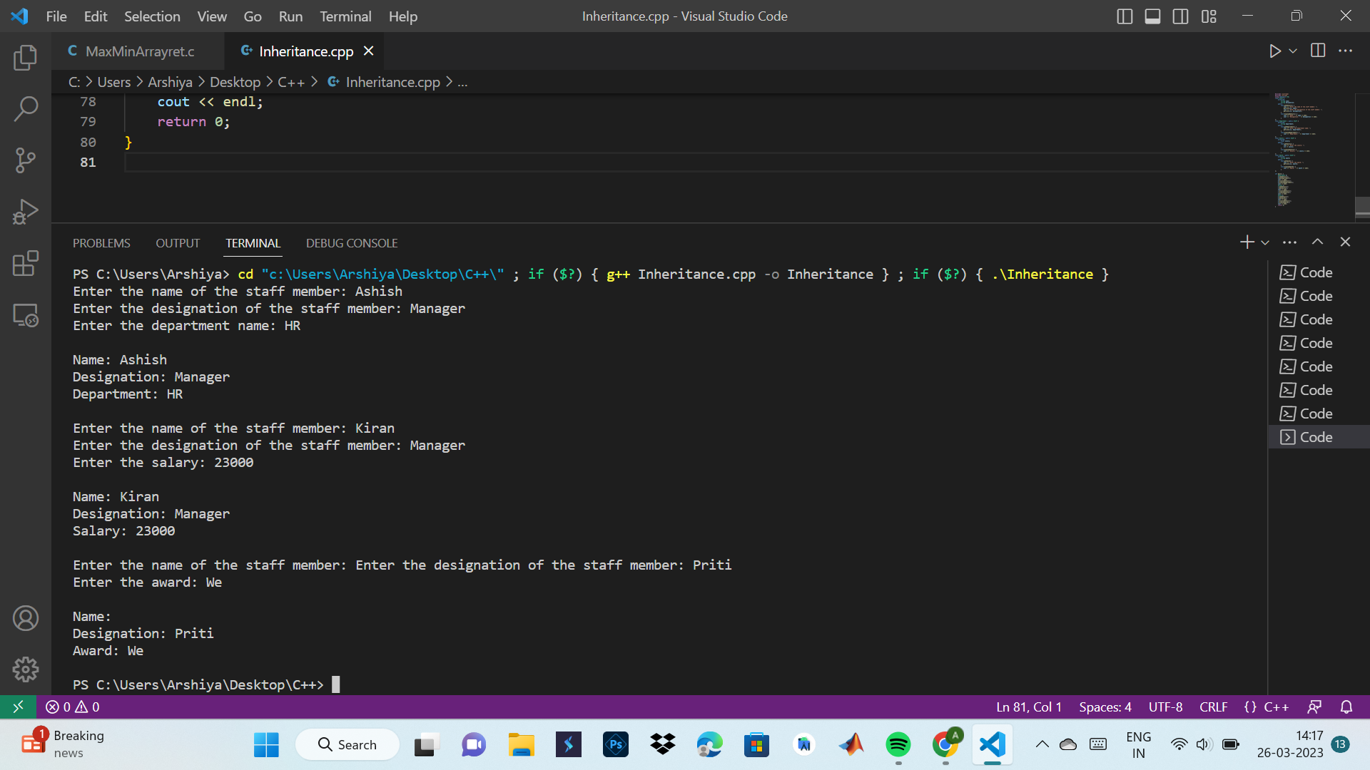

**2. Write a Program to design a class to represent a matrix. The class should have the functionality to insert and retrieve the elements of the matrix. Also, create two functions to add and multiply elements of two matrices.**

#include <iostream>

using namespace std;

class Matrix {

private:

int rows;

int cols;

int **data;

public:

// Constructor

Matrix(int rows, int cols) {

this->rows = rows;

this->cols = cols;

data = new int*[rows];

for (int i = 0; i < rows; i++) {

data[i] = new int[cols];

}

}

// Set the element at position (i,j) to val

void setElement(int i, int j, int val) {

data[i][j] = val;

}

// Get the element at position (i,j)

int getElement(int i, int j) {

return data[i][j];

}

// Add two matrices and return the result

Matrix add(Matrix other) {

Matrix result(rows, cols);

for (int i = 0; i < rows; i++) {

for (int j = 0; j < cols; j++) {

result.setElement(i, j, data[i][j] + other.getElement(i, j));

}

}

return result;

}

// Multiply two matrices and return the result

Matrix multiply(Matrix other) {

Matrix result(rows, other.cols);

for (int i = 0; i < rows; i++) {

for (int j = 0; j < other.cols; j++) {

int sum = 0;

for (int k = 0; k < cols; k++) {

sum += data[i][k] * other.getElement(k, j);

}

result.setElement(i, j, sum);

}

}

return result;

}

// Display the matrix

void display() {

for (int i = 0; i < rows; i++) {

for (int j = 0; j < cols; j++) {

cout << data[i][j] << " ";

}

cout << endl;

}

}

// Destructor

~Matrix() {

for (int i = 0; i < rows; i++) {

delete[] data[i];

}

delete[] data;

}

};

int main() {

int rows1, cols1, rows2, cols2;

cout << "Enter the number of rows in Matrix 1: ";

cin >> rows1;

cout << "Enter the number of columns in Matrix 1: ";

cin >> cols1;

Matrix m1(rows1, cols1);

cout << "Enter the elements of Matrix 1:" << endl;

for (int i = 0; i < rows1; i++) {

for (int j = 0; j < cols1; j++) {

int val;

cin >> val;

m1.setElement(i, j, val);

}

}

cout << "Enter the number of rows in Matrix 2: ";

cin >> rows2;

cout << "Enter the number of columns in Matrix 2: ";

cin >> cols2;

Matrix m2(rows2, cols2);

cout << "Enter the elements of Matrix 2:" << endl;

for (int i = 0; i < rows2; i++) {

for (int j = 0; j < cols2; j++) {

int val;

cin >> val;

m2.setElement(i, j, val);

}

}

// Display the matrices

cout << "Matrix 1:" << endl;

m1.display();

cout << "Matrix 2:" << endl;

m2.display();

// Add the matrices and display the result

if (rows1 == rows2 && cols1 == cols2) {

Matrix result = m1.add(m2);

cout << "Sum of Matrix 1 and Matrix 2:" << endl;

result.display();

} else {

cout << "Matrices cannot be added because they have different dimensions." << endl;

}

// Multiply the matrices and display the result

if (cols1 == rows2) {

Matrix result = m1.multiply(m2);

cout << "Product of Matrix 1 and Matrix 2:" << endl;

result.display();

}

else {

cout << "Matrices cannot be multiplied because the number of columns in Matrix 1 is not equal to the number of rows in Matrix 2." << endl;

}

}

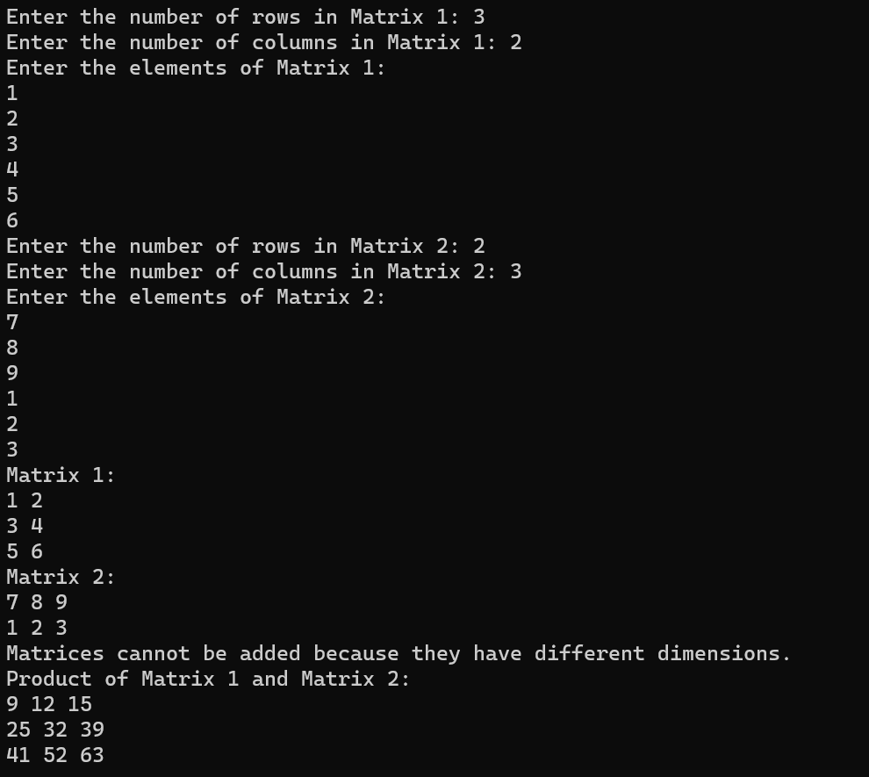

**3. Write a class representing bank accounts. The class should have the following data members: Customer Name, Account Number, Type of Account (Savings/Current, etc), and Account Balance. The class should allow basic operations like creating a new account, deposit an amount, withdraw money after checking the balance, display account details.**

#include <iostream>

#include <string>

using namespace std;

class Bank_acounts

{

string name;

int acc_n;

string acc_type;

double balance;

public:

//creating a constructor

Bank_acounts()

{

name = "JON DOE";

acc_n = 55555;

acc_type = "SAVING";

balance = 0.00;

}

void setter_details()

{

cout << endl

<< "Enter the name -> ";

cin >> name;

cout << endl

<< "Enter Account number -> ";

cin >> acc_n;

cout << endl

<< "Enter the account type -> ";

cin >> acc_type;

cout << endl

<< "Enter the amount to deposit -> ";

cin >> balance;

}

void getter_details()

{

cout << endl

<< "CUSTOMER NAME: " << name << endl

<< "ACCOUNT NUMBER: " << acc_n << endl

<< "ACCOUNT TYPE: " << acc_type << endl

<< "BALANCE: " << balance << endl

<< endl

<< "**************************" << endl

<< endl;

}

void deposit(float amt)

{

balance = balance + amt;

cout<<"The new balance is -> "<<balance;

}

void withdraw(float amt)

{

if (balance - amt < 0)

{

cout << endl

<< "Insufficient Balance!" << endl;

return;

}

balance = balance - amt;

cout<<"The remaining balance is -> "<<balance;

}

void check_balance()

{

cout << endl

<< "The current balance is -> " << balance << endl;

}

int acc_number()

{

return acc_n;

}

friend void operations(Bank_acounts);

};

void operations(Bank_acounts object[])

{

int choice;

int repeat;

double amt;

int number;

int i = 0;

int flag = 0;

do

{

cout << endl

<< "1. Create New account" << endl

<< "2 Login" << endl

<< "3. Exit" << endl;

cout << "Enter your choice -> ";

cin >> choice;

switch (choice)

{

case 1:

cout << endl

<< "Enter the details " << endl;

object[i].setter_details();

i++;

break;

case 2:

cout << endl

<< "Please enter your account number -> ";

cin >> number;

for (int j = 0; j < i; j++)

{

flag = 0;

if (number == object[j].acc_number())

{

do

{

flag = 1;

cout << endl

<< "**************** LOGIN SUCCESSFULLY ****************" << endl;

cout << "\t1. Display Details" << endl

<< "\t2. Check Balance" << endl

<< "\t3. Cash Withdraw" << endl

<< "\t4. Cash Deposit" << endl;

cout << "Enter your choice -> ";

cin >> choice;

switch (choice)

{

case 1:

object[j].getter_details();

break;

case 2:

object[j].check_balance();

break;

case 3:

cout << endl

<< "Enter the amount to withdraw -> ";

cin >> amt;

object[j].withdraw(amt);

break;

case 4:

cout << endl

<< "Enter the amount to deposit -> ";

cin >> amt;

object[j].deposit(amt);

break;

default:

break;

}

cout<<endl<<"Press 1 to continue -> ";

cin>>repeat;

} while (repeat == 1);

break;

}

}

if (flag == 0)

{

cout << endl

<< "*************** NO RECORD FOUND! ***************" << endl;

}

default:

exit(0);

}

} while (1);

}

int main()

{

Bank_acounts object[5];

operations(object);

}

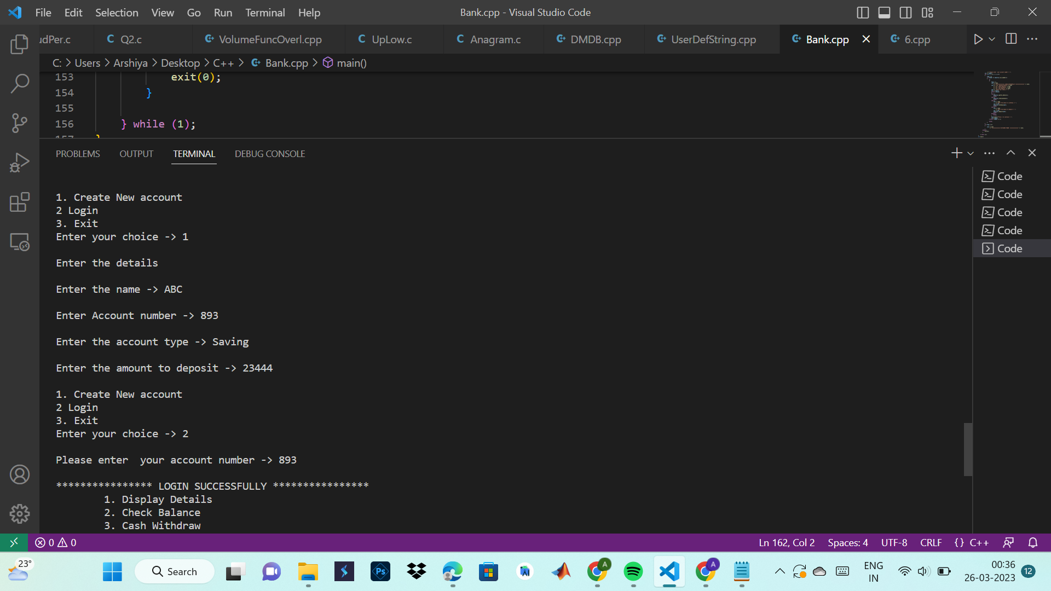

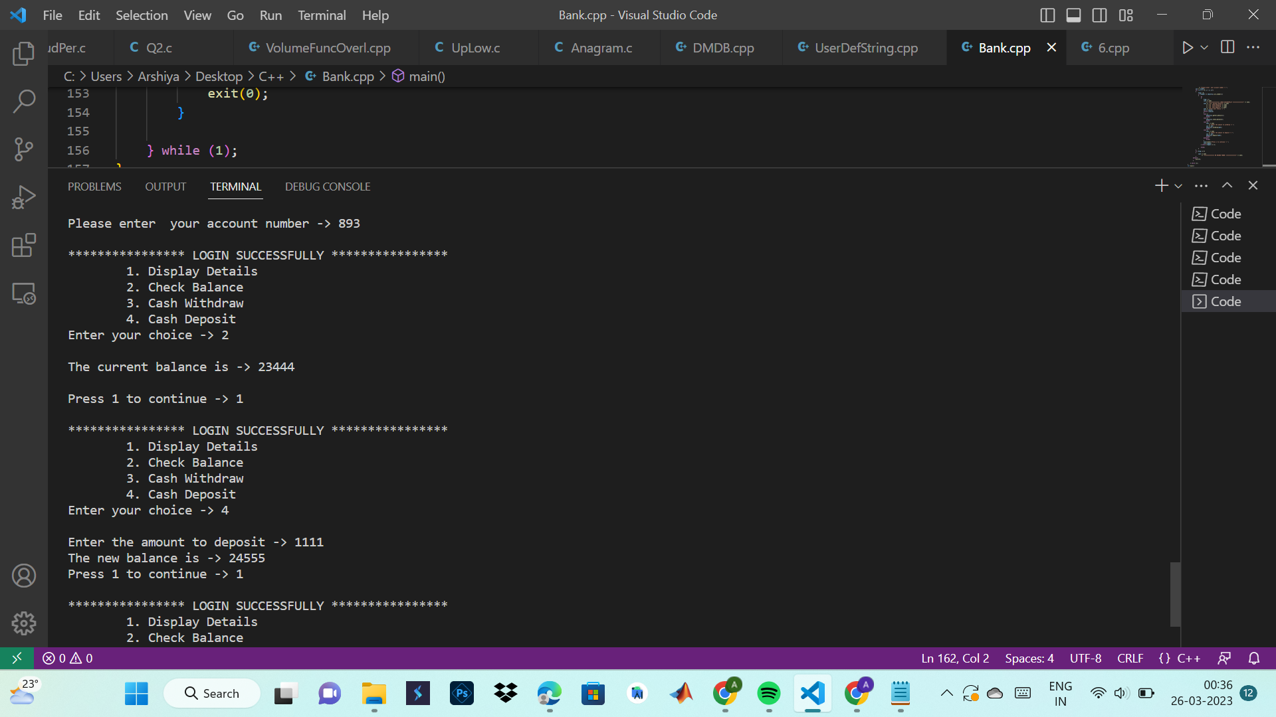

**4. Write a program to sort two numbers using call by reference. Smallest number should be output first.**

#include <iostream>

using namespace std;

void sortTwoNumbers(int& num1, int& num2) {

if(num1 > num2) {

swap(num1, num2);

}

}

int main() {

int num1, num2;

cout << "Enter two numbers: ";

cin >> num1 >> num2;

sortTwoNumbers(num1, num2);

cout << "Sorted numbers: " << num1 << ", " << num2 << endl;

return 0;

}

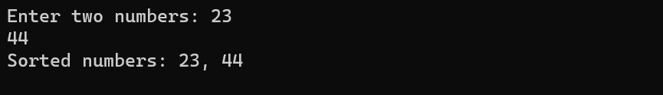

**5. Create two classes KILOS and POUNDS which store the value of weights. KILOS stores weight in kilograms and grams and POUNDS in pounds and ounces. Write a program using friend function to add weight of a KILOS object to weight of POUNDS object. Store the result as POUNDS object. (Use 1 pound = 16 ounces, 1 ounce = 28 grams)**

#include <iostream>

#include <cmath>

using namespace std;

class Pound;

class Kilo

{

float kg;

float gram;

public:

//creating a constructor

Kilo()

{

kg = 10.00;

gram = 500.00;

}

float get_kg()

{

cout << endl

<< endl

<< " ************************* WEIGHT IN KILOGRAM ************************* " << endl

<< endl;

cout << endl

<< "Enter the number of kg -> ";

cin >> kg;

return kg;

}

float get_gram()

{

cout << endl

<< "Enter the grams -> ";

cin >> gram;

return gram;

}

void set_data()

{

cout << endl

<< "Kg: " << kg << " and Gm: " << gram << endl;

}

friend void conversion(Kilo, Pound);

};

class Pound

{

float pound;

float ounce;

public:

//creating a constructor

Pound()

{

pound = 10.00;

ounce = 500.00;

}

float get_pound()

{

cout << endl

<< endl

<< " ************************* WEIGHT IN POUNDS ************************* " << endl

<< endl;

cout << endl

<< "Enter the number of pound -> ";

cin >> pound;

return pound;

}

float get_ounce()

{

cout << endl

<< "Enter the ounce -> ";

cin >> ounce;

return ounce;

}

void set_data()

{

cout << endl

<< "pound: " << pound << " and ounce: " << ounce << endl;

}

friend void conversion(Kilo, Pound);

};

void conversion(Kilo k, Pound p)

{

int choice;

int temp1,temp2;

do

{

cout << endl

<< "1. kg-gm to lbs-oz convertor" << endl

<< "2. lbs-oz to kg-gm convertor" << endl

<< "3. Exit" << endl

<< "Enter your choice -:> ";

cin>>choice;

switch (choice)

{

case 1:

temp1 = k.get_kg();

temp2 = k.get_gram();

p.pound = temp1 * (2.20462);

p.ounce = temp2 * (0.035274);

p.set_data();

break;

case 2:

temp1 = p.get_pound();

temp2 = p.get_ounce();

k.kg = temp1 * (0.453592);

k.gram = temp2 * (28.3495);

k.set_data();

default:

exit(0);

}

} while (1);

}

int main()

{

Kilo k;

Pound p;

conversion(k, p);

return 0;

}

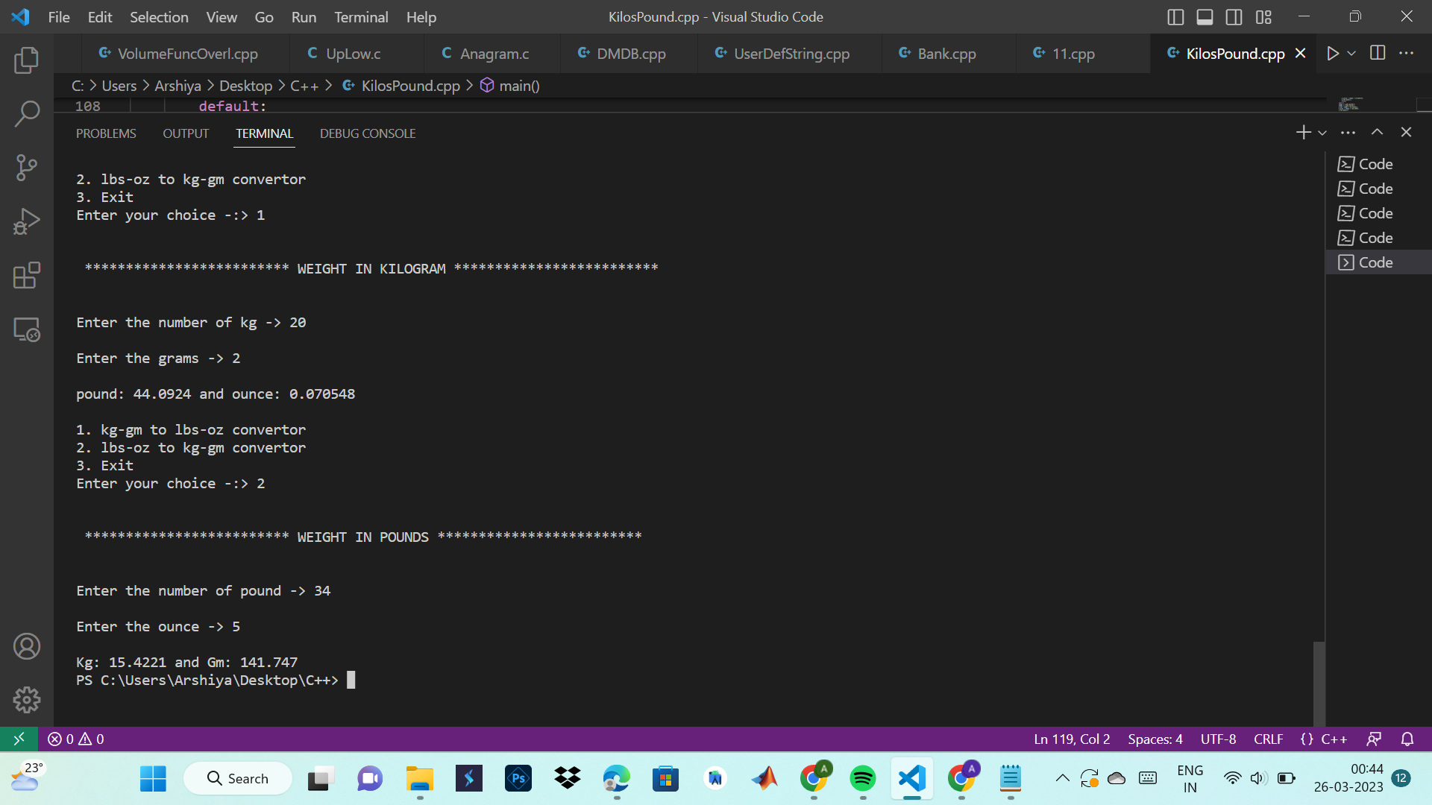

**6. Write an overloaded volume function to calculate the volume of a cube (side*side*side), a cuboid (l*b*h), and a circle.**

#include<iostream>

using namespace std;

int getVolume(int side)

{

return side*side*side;

}

float getVolume(float radius)

{

return (4/3)*(3.14)*radius*radius*radius;

}

float getVolume(float length, float breadth, float height)

{

return length*breadth*height;

}

int main()

{

while(1)

{

int choice;

int t1,t2,t3,side;

float radius;

cout<<"\n 1.Volume of cube \n 2.Volume of cuboid \n 3.Volume of sphere \n 4.Exit";

cout<<"\n Enter your choice : ";

cin>>choice;

switch(choice)

{

case 1 :

cout<<"\n Enter length of side of cube : ";

cin>>side;

cout<<"\n Volume of cube is : "<<getVolume(side);

break;

case 2 :

cout<<"\n Enter length of cuboid : ";

cin>>t1;

cout<<"\n Enter breadth of cuboid : ";

cin>>t2;

cout<<"\n Enter height of cuboid : ";

cin>>t3;

cout<<"\n Volume of cuboid is : "<<getVolume(t1,t2,t3);

break;

case 3 :

cout<<"\n Enter radius of sphere : ";

cin>>radius;

cout<<"\n Volume of sphere is : "<<getVolume(radius);

break;

default :

exit(0);

}

}

return 0;

}

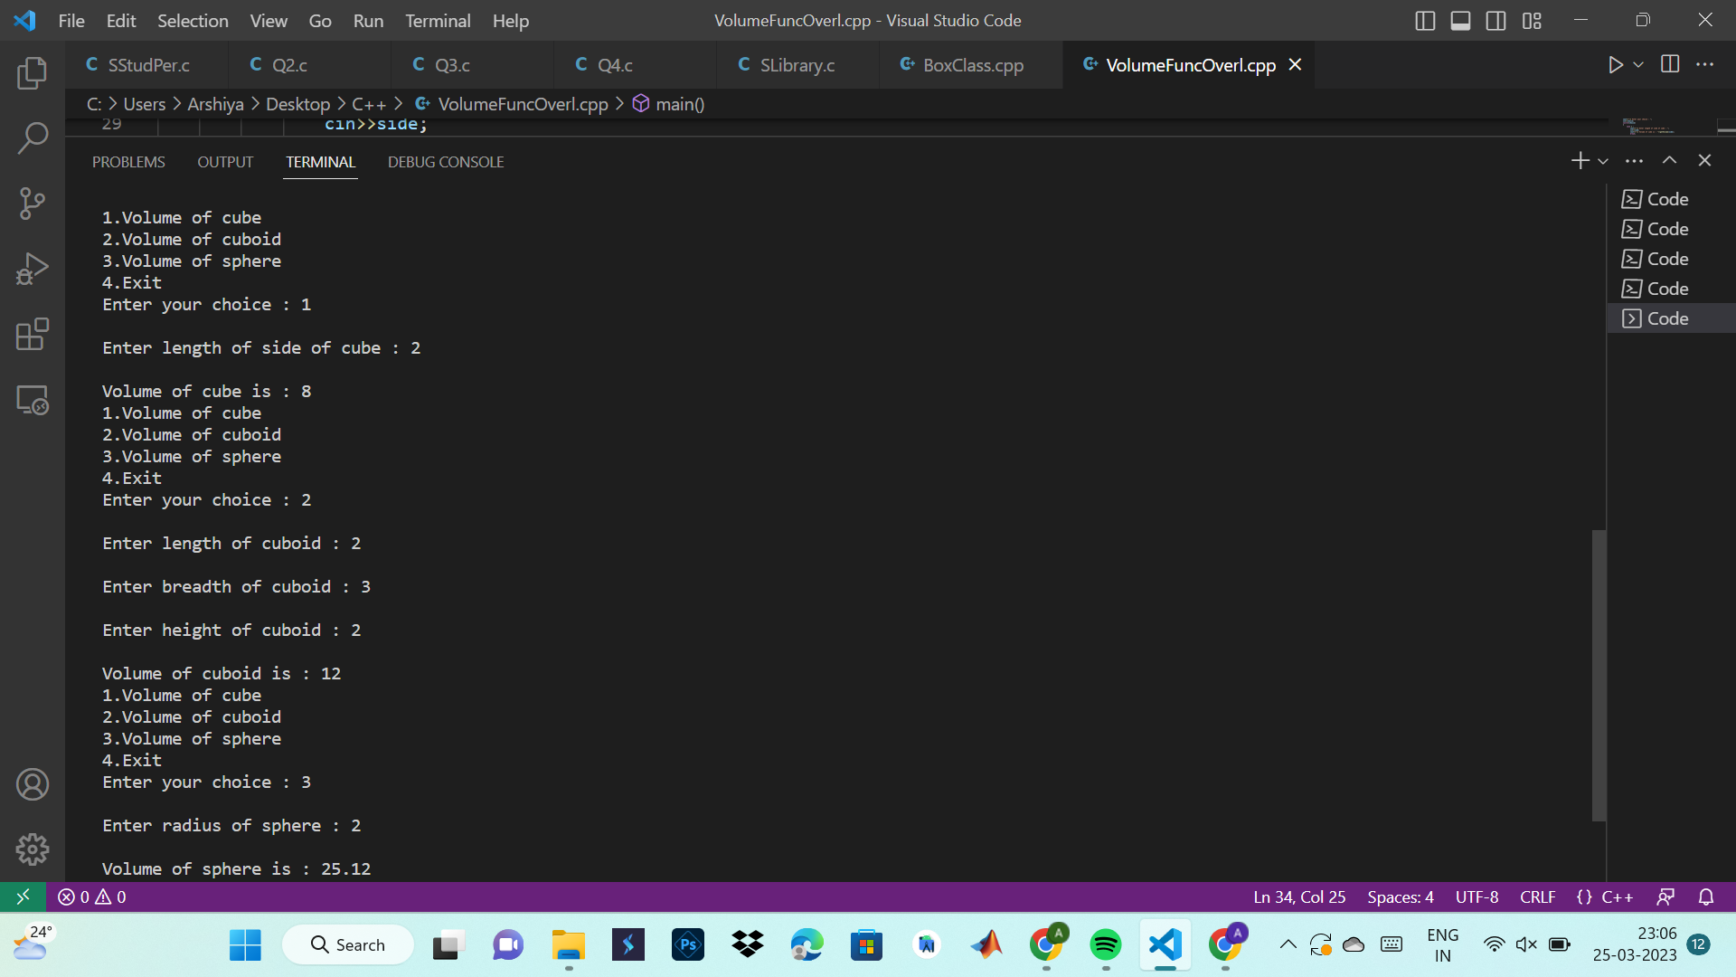

**7. Write a box class with class member’s length, breadth, height, and a function to calculate the volume of the box. Constructor should be passed arguments for length, breadth, and height. Also, define a second constructor which takes default height value of 10.**

#include<iostream>

using namespace std;

class Box

{

int length;

int breadth;

int height;

public :

int volume;

Box()

{

height=10;

length=10;

breadth=10;

}

Box(int length, int breadth, int height)

{

this->length=length;

this->breadth=breadth;

this->height=height;

}

Box(int length, int breadth)

{

this->length=length;

this->breadth=breadth;

height=10;

}

void calVolume()

{

cout<<"\n Enter the length of box : ";

cin>>length;

cout<<"\n Enter the breadth of box : ";

cin>>breadth;

cout<<"\n Enter the height of box : ";

cin>>height;

volume=length*breadth*height;

cout<<"\n Volume of the box is : "<<volume;

}

};

int main()

{

Box b(10,15,20);

b.calVolume();

return 0;

}

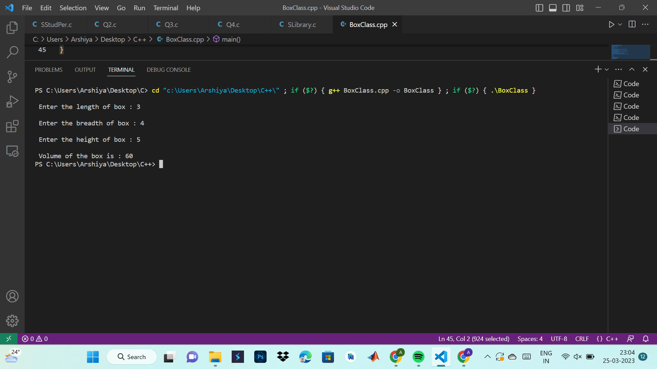

**8. Design a Point class with coordinates x and y representing point on the plane (use constructors). Design a Polar class that represents class using polar coordinates radius(r) and angle(a). Write a program which takes input data for a Point object and performs type conversion so as to convert the Point data into Polar data. Use the following formulas where required:**

**x = r * cos(a);**

**y = r * sin(a);**

**a = atan(y/x);**

**r = sqrt(x*x + y*y);**

#include <iostream>

#include <cmath>

using namespace std;

class Point {

private:

double x;

double y;

public:

// Constructor with two arguments for x and y coordinates

Point(double xCoord, double yCoord) {

x = xCoord;

y = yCoord;

}

// Getter functions for x and y coordinates

double getX() { return x; }

double getY() { return y; }

};

class Polar {

private:

double r;

double a;

public:

// Constructor with two arguments for radius and angle

Polar(double radius, double angle) {

r = radius;

a = angle;

}

// Getter functions for radius and angle

double getR() { return r; }

double getA() { return a; }

};

// Function to convert a Point object to a Polar object

Polar convertToPolar(Point p) {

double r = sqrt(p.getX() * p.getX() + p.getY() * p.getY());

double a = atan(p.getY() / p.getX());

return Polar(r, a);

}

int main() {

// Create a Point object with coordinates (3, 4)

Point p(3, 4);

// Convert the Point object to a Polar object

Polar polar = convertToPolar(p);

// Print the polar coordinates

cout << "Polar coordinates: (" << polar.getR() << ", " << polar.getA() << ")" << endl;

return 0;

}



**9. Create two classes DM and DB which store the values of distance. DM stores distance in meters and centimeters. DB stores distance in feet and inches. Write a program that can read values for the class object and add one object of DM with another object of DB. Use a friend function to carry out the addition operation and this function will display answers in meters and centimeters.**

#include<iostream>

using namespace std;

class DM{

public:

int meters;

int centi;

//creating a constructor of DM class

DM()

{

meters = 0;

centi = 0;

}

};

class DB :public DM{

int feet;

int inches;

public:

friend void addition(DB &feet_object);

};

void addition(DB &feet_object)

{

int m;

int c;

int f;

int i;

cout<<"Enter distance in meters -> ";

cin>>m;

cout<<"Enter distance in inches -> ";

cin>>i;

cout<<"Enter distance in feet -> ";

cin>>f;

cout<<"Enter distance in centimeters -> ";

cin>>c;

feet_object.feet = f;

feet_object.meters = m;

feet_object.centi = c;

feet_object.inches = i;

//adding feet to meters and centimeters to inches

float op1 = feet_object.meters * (3.28084) + feet_object.feet;

float op2 = feet_object.inches + feet_object.centi * (0.393701);

cout<<endl<<"Final result(in feet and centimeter) is -> "<<op1<< " and "<<op2;

}

int main()

{

DM meter_object;

DB feet_object;

cout<<endl<<"Enter the details...."<<endl;

addition(feet_object);

return 0;

}

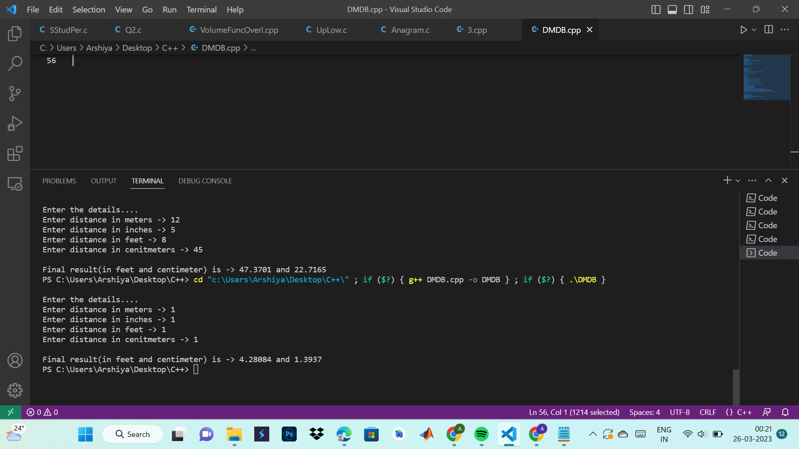

**10. Define a class String that could work as a user-defined string type. Include constructors that will enable us to create an uninitialized string.**

#include<iostream>

#include "string.h"

using namespace std;

class test_string{

char characters[75];

public:

//creating a constructor

test_string()

{

cout<<"The default constructor is called......"<<endl;

strcpy(characters,"This is a test string!");

}

void get_string()

{

cout<<endl<<"Please enter the required string! -> ";

fgets(characters,75,stdin);

}

void display()

{

printf("\nSTRING IS -> %s\n",characters);

}

};

int main()

{

test_string object;

object.display();

object.get_string();

object.display();

return 0;

}

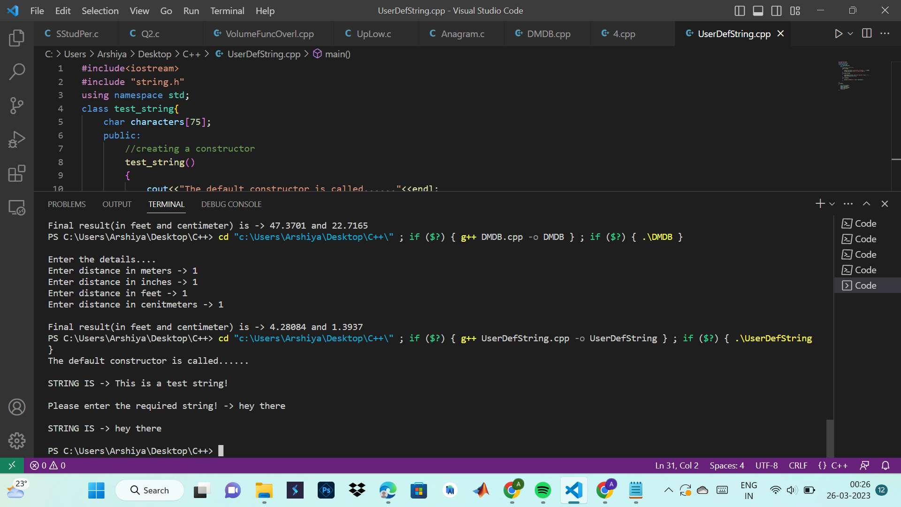

**FILES**

**1. Write a C program to count characters, words, and lines in a text file.**

#include <stdio.h>

#include <stdlib.h>

int main()

{

FILE *fp;

char filename[100], ch;

int chars = 0, words = 0, lines = 0;

printf("Enter the filename: ");

scanf("%s", filename);

fp = fopen(filename, "r");

if (fp == NULL)

{

printf("Error opening file.\n");

exit(1);

}

while ((ch = fgetc(fp)) != EOF)

{

chars++;

if (ch == ' ' || ch == '\n' || ch == '\t')

{

words++;

}

if (ch == '\n')

{

lines++;

}

}

if (chars > 0)

{

words++;

lines++;

}

printf("Characters: %d\n", chars);

printf("Words: %d\n", words);

printf("Lines: %d\n", lines);

fclose(fp);

return 0;

}

**OUPTUT :**

Enter the filename: sample.txt

Characters: 102

Words: 16

Lines: 3

**2. Write a C program to merge two files into a third file.**

#include <stdio.h>

#include <stdlib.h>

int main()

{

FILE *f1, *f2, *f3;

char filename1[100], filename2[100], filename3[100];

char ch;

printf("Enter the first filename: ");

scanf("%s", filename1);

printf("Enter the second filename: ");

scanf("%s", filename2);

printf("Enter the third filename: ");

scanf("%s", filename3);

f1 = fopen(filename1, "r");

f2 = fopen(filename2, "r");

f3 = fopen(filename3, "w");

if (f1 == NULL || f2 == NULL || f3 == NULL)

{

printf("Error opening files.\n");

exit(1);

}

while ((ch = fgetc(f1)) != EOF)

{

fputc(ch, f3);

}

while ((ch = fgetc(f2)) != EOF)

{

fputc(ch, f3);

}

printf("Files merged successfully.\n");

fclose(f1);

fclose(f2);

fclose(f3);

return 0;

}

**OUTPUT :**

Enter the first filename: file1.txt

Enter the second filename: file2.txt

Enter the third filename: merged.txt

Files merged successfully.

**3. Write a C program to remove empty lines from a text file.**

#include <stdio.h>

#include <stdlib.h>

#include <string.h>

#define BUFFER_SIZE 1000

int main()

{

FILE *fp1, *fp2;

char buffer[BUFFER_SIZE];

char filename[100];

printf("Enter the filename: ");

scanf("%s", filename);

fp1 = fopen(filename, "r");

fp2 = fopen("temp.txt", "w");

if (fp1 == NULL || fp2 == NULL)

{

printf("Error opening files.\n");

exit(1);

}

while (fgets(buffer, BUFFER_SIZE, fp1) != NULL)

{

if (strcmp(buffer, "\n") != 0)

{

fputs(buffer, fp2);

}

}

fclose(fp1);

fclose(fp2);

remove(filename);

rename("temp.txt", filename);

printf("Empty lines removed successfully.\n");

return 0;

}

**OUTPUT :**

Enter the filename: input.txt

Empty lines removed successfully.

**4. Write a C program to convert uppercase to lowercase characters and vice versa in a text file**

#include <stdio.h>

#include <stdlib.h>

int main()

{

FILE *fp1, *fp2;

char ch;

char filename[100];

printf("Enter the filename: ");

scanf("%s", filename);

fp1 = fopen(filename, "r");

fp2 = fopen("temp.txt", "w");

if (fp1 == NULL || fp2 == NULL)

{

printf("Error opening files.\n");

exit(1);

}

while ((ch = fgetc(fp1)) != EOF)

{

if (ch >= 'a' && ch <= 'z')

{

ch = ch - 'a' + 'A'; // convert lowercase to uppercase

}

else if (ch >= 'A' && ch <= 'Z')

{

ch = ch - 'A' + 'a'; // convert uppercase to lowercase

}

fputc(ch, fp2);

}

fclose(fp1);

fclose(fp2);

remove(filename);

rename("temp.txt", filename);

printf("Case converted successfully.\n");

return 0;

}

**OUTPUT :**

Enter the filename: input.txt

Case converted successfully.